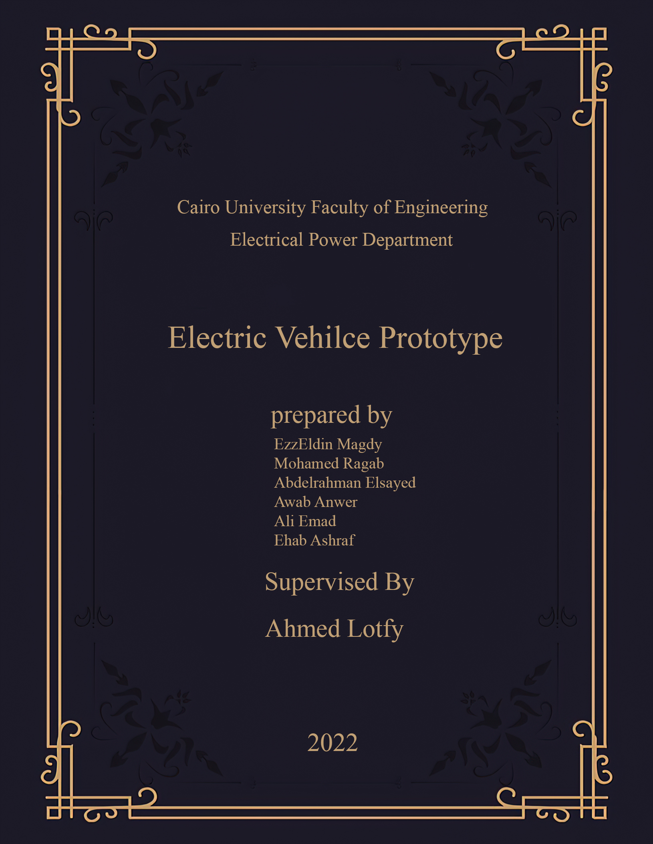

Table of Content   
Introduction ………......................................................................................................................................................... 1  
CHAPTER 1 || System Overview ................................................................................................................................... 2  
 1.1 BLDC Motors ................................................................................................................................................................ 3  
CHAPTER 2 || INVERTER DESGIN ................................................................................................................................. 9 1.1 Components Sizing ...................................................................................................................................................... ….9 1.2 Schematics ...................................................................................................................................................................... 10  
 1.3 Three Phase Inverter Waveforms ................................................................................................................................ 11 CHAPTER 3 || SPEED CONTROL .................................................................................................................................... 15 1.1 Open Loop Motor Performance …................................................................................................................................ …15 1.2 Speed Measurements .................................................................................................................................................. ….21  
 1.3 PI Controller ……………………………................................................................................................................................... 29   
 1.4 Cascaded Control ……………………................................................................................................................................... 36  
CHAPTER 4 || Braking ……….......................................................................................................................................... 40CHAPTER 5 || IoT ………................................................................................................................................................. 50 Conclusion ………........................................................................................................................................................... 71  
References ………........................................................................................................................................................... 72

**CHAPTER 0 || Introduction**

**Objective**

The objective of this project is to design and implement a low-cost and efficient electric drive system for an electric vehicle. This will be achieved through the local manufacture of the propulsion system and protection module together with the two main modules: three-phase inverter in addition to the main control unit of the system will be designed by several control algorithms (Scaler Control V / F, Vector Control FOC) which makes it withstand various operating conditions such as: starting at heavy loads, obstacles in the road and energy recovery during braking. In addition to making the electric car environmentally friendly by charging it with renewable energy through solar panels.

**Introduction**

Global warming is becoming a very important global issue. It was even one of the three main topics in the recent 2009 G8 Summit. Carbon dioxide (CO2) emission is the main contributor of greenhouse gas which leads to global warming. Transportation accounts for more than 20% of man-made CO2. It is therefore eighty desirables to reduce greenhouse gas emission by improving vehicles’ fuel efficiency. On the other hand, the number of electric machines installed in modern vehicles has been increasing at a rapid pace. The more luxury the vehicle, the more electric machines will be equipped. Well optimized electric machines with high efficiency will therefore play a pivotal role in improving the vehicles’ overall efficiency, and thus in reducing the CO2 emission to mitigate global warming. An apparent trend that electrical power steering (EPS) is becoming an alternative to the hydraulic power steering (HPS) can be seen in recent developments in automotive industry. In the HPS system, a pump driven by the engine is constantly running to keep the hydraulic pressure, no matter assistance is required or not. While in the EPS system, the electric motor is driven only when the steering wheel is turned. EPS thus offers much better fuel economy, which can account for 3% improvements in fuel efficiency. Electric machines, the key actuators in the EPS system, are crucial in influencing the vehicle’s steering performance

Permanent magnet (PM) brushless machines have drawn considerable interests from both industrial and academic research communities so it was our choice

Recently in Egypt, the use of electric bicycles and electric vehicles has increased throughout Egyptian cities. The goal is to achieve a healthier lifestyle for the residents as well as reduce fuel consumption and traffic congestion in major cities. This project is based on the implementation and design of a high-performance electric bike and modern technology that increases the efficiency of the system, thus reducing the size of the batteries and thus reducing the weight of the bike. The electric bike is a promising alternative means of transportation. It offers all the benefits of a regular bike but offers a completely different experience than riding a gas scooter or a motorbike, smooth movement and completely silent. In this project our main goal is to achieve an electric vehicle with good specifications, find the best motor control technologies, and reduce wasted energy in the vehicle

**| CH1 | System Overview**

**CHAPTER 1 || SYSTEM OVERVIEW**

The whole system of the electric vehicle is made up of several complex and interconnected sub-systems. If we look at the following figure fig[1] from left to right in order, we will first see the battery pack and its charger, which are responsible for providing the vehicle with the necessary energy during the trip, and then comes after that the DC-DC converter which raises the voltage to suit the input of the three-phase inverter, which in turn converts the continuous voltage into a three-phase voltage to fit the motor, which is a BLDC motor, that outputs the appropriate torque for the vehicle, which comes at the request of the driver and with the help of the main controller.

Our interest in this project will be largely focused on the engine with the inverter, various inverter control methods and operating modes such as open loop control and closed loop control.

In the beginning we will discuss the hardware design part of the inverter circuit and the motor, and then we will discuss the software and control part, and later we will talk about the Internet of Things and how to link it with the vehicle system and we will shed light on its importance in the future and finally we will talk about the brake system.

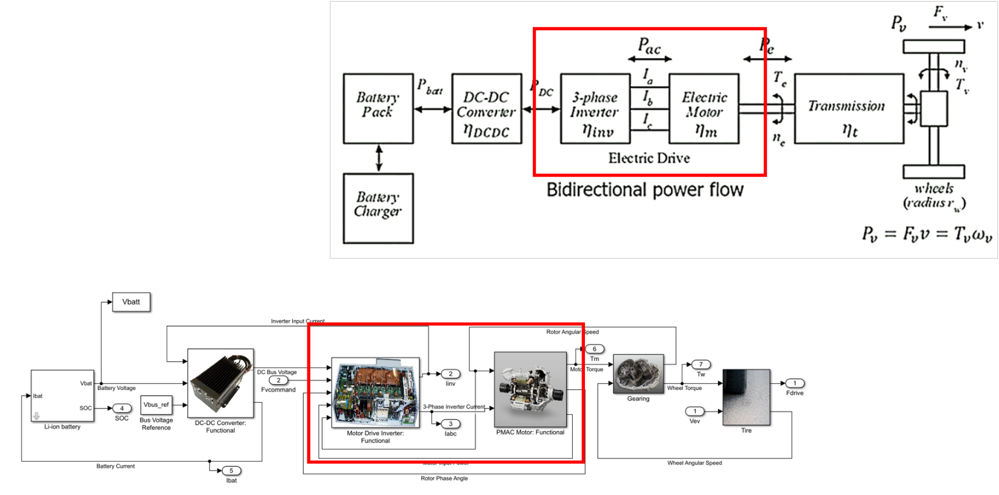

Figure 1: System Overview

**| CH1 | System Overview**

**1.1 BLDC OVERVIEW**

Using of Permanent Magnet in electrical machines have so many benefits and advantages then electromagnetic excitation machines these are zero excitation losses result in high efficiency, simple construction, low cost less maintenance and high torque or high output power per unit volume. Due to high power to weight ratio, high torque, good dynamic control for variable speed applications, absence of brushes and commutator make Brushless dc (BLDC) motor, best choice for high performance applications. Due to the absence of brushes and commutator there is no problem of mechanical wear of the moving parts. As well, better heat dissipation property and ability to operate at high speeds make them superior to the conventional dc machine. However, the BLDC motor constitutes a more difficult problem than its brushed counterpart in terms of modelling and control system design due to its multi-input nature and coupled nonlinear dynamics. Due to the simplicity in their control, Permanent-magnet brushless dc motors are more accepted used in high-performance applications. In many of these applications, the production of ripple-free torque is of primary concern. There are three main sources of torque ripple production in BLDCMs: cogging torque, reluctance torque, and mutual torque. Cogging torque is created by the stator slots interacting with the rotor magnetic field and is independent of stator current excitation. Reluctance torque is caused by the variation in phase inductance with respect to position. Mutual torque is created by the mutual coupling between the stator winding current and rotor magnetic field. In general, surface-mounted magnets are used in many high-performance BLDCM’s. Because the permeability of the magnet material is nearly equal to that of air, the effective air gap is enlarged by the magnet. This fact ensures minimum armature effect on the rotor field from the stator currents. If a BLDCM is designed with low saliency and either the stator slots or rotor magnets are skewed by one slot pitch, the effects of the first two torque components can be greatly reduced. Therefore, if the waveforms of the phase back EMF and phase current are perfectly matched, torque ripple is minimized and the mutual torque component is maximized. In this paper finally closed loop speed control is done by using PI controller and hysteresis current controller loop is added with speed feedback loop and it is observed that there is a reduction in the current ripple hence torque ripple is minimized.

**| CH1 | System Overview**

**1.2 Difference Between Brushed DC Motor and BLDC Motor**

Brushed DC Motor It has permanent magnets inside the outer body and a rotor inside. And it spins 180-degrees we electric current is applied. Carbon Brushes contact the stator when the rotor spins and it flipping the magnetic field and enabling the rotor to spin 360-degrees.

Benefits

Disadvantages

• High Maintenance Cost

• Lower Speed

• High starting torque

• Low cost

• Suited to Industrial Environment

Brushless DC Motor

Like brushed motor, it works by alternating the polarity of windings inside the motor. It is essentially an inside out brushed motor, which eliminates the need for brushes. In a brushless DC motor, the permanent magnets are fitted to the rotor, with the windings on the stator.

Disadvantages

• Requires a controller

• Cost of the controller and the Driver Circuit

Benefits

• Long lifespan

• Efficiency

• Quiet operation

**1.3 Difference Between BLDC Motor and PMSM**

As we said BLDC motor has a permanent magnet rotor and a three phase windings stator, it is working on the Lorentz principle which states that whenever we placed a current-carrying conductor in a magnetic field it experiences a force. The stator windings in a trapezoidal manner. Hence, the motor back emf will be trapezoidal and it will produce torque repulsion.

**Permanent Magnet Synchronous Motor**

It is working the same as a synchronous motor, when a three-phase current energized the stator windings it creates an emf which affect the rotor and it start rotating at synchronous speed. The coil wound over is in a sinusoidal manner. Hence, the back emf will be sinusoidal and it will produce repulsion.

**| CH1 | System Overview**

|  |  |  |
| --- | --- | --- |
| Operation | BLDC M | PMSM |
| Current required | DC | AC |
| Back EMF wave | Trapezoidal | Sinusoidal |
| Torque ripple at commutation | Present | Absence |
| Performance | Poor | Good |
| Cost | Low | High |
| Torque and Efficiency | Lower | Higher |
| Noise | Lower | Higher |

**1.4 Wheel Hub Motor Definition**

The wheel hub motor (also called wheel motor, wheel hub drive, hub motor or in-wheel motor) is an electric motor that is incorporated into the hub of a wheel and drives it directly.

**Why BLDC Motor is Commonly in E-bike?**

The BLDC motor has a longer life because no brushes are needed. so, it has a high starting torque, high no-load speed, high efficiency 95-98% and small energy losses. And due to traction characteristics, it is the most preferred motor for the electric vehicle. It has two types:

1. Out-runner type BLDC Motor (Hub Motors)

2. In-runner type BLDC Motor

3. Low Noise (because no mechanical parts)

**1.5 BLDC Motor BLDC Motor Structure**

We can consider BLDC motors as a flipped version of brushed DC motors as we have:

• Permanent magnet represents the rotor

• 3 phase coils represent the stator

**1.6 BLDC Motor’s Principle of Operation**

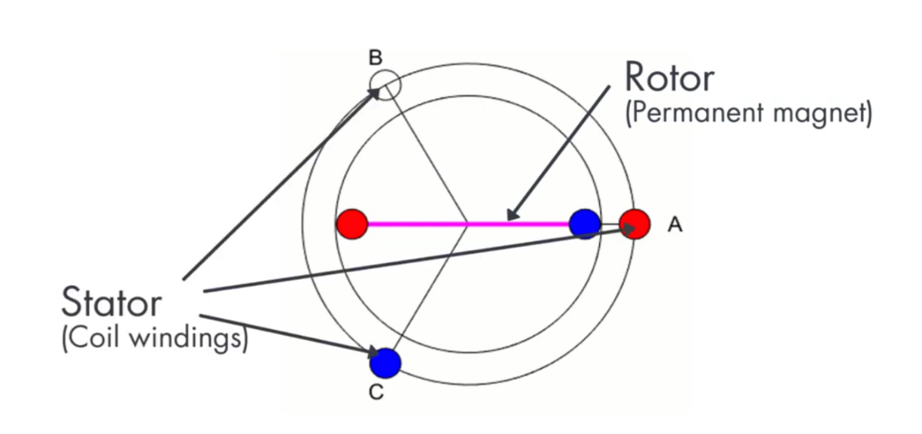

Figure 2: BLDC Motor Structure

**| CH1 | System Overview**

We will use simple configuration where the rotor only consists of a single pole pair and the stator consists of three coils spaced at 120**o**. Applying voltage across two phases A and C generates a combined magnetic field along (the dashed line).

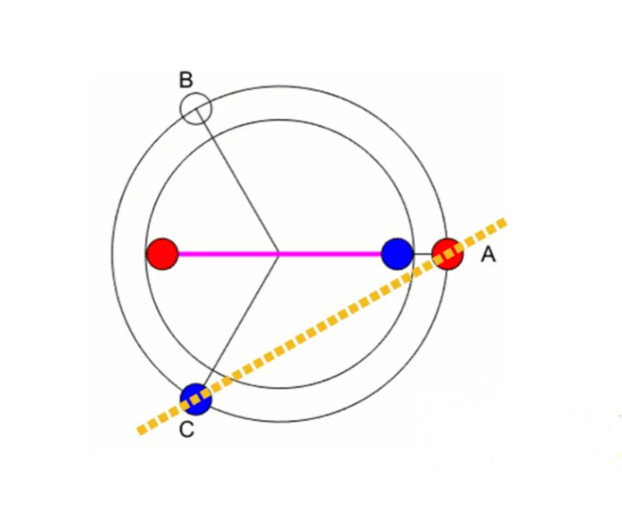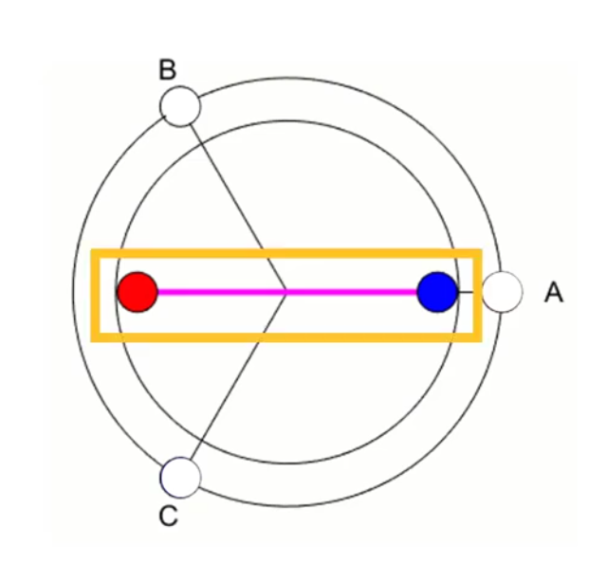

Figure 3: Rotor Movement

The rotor now starts to rotate to align itself with the stator magnetic field and There are six possible ways of energizing coil pairs

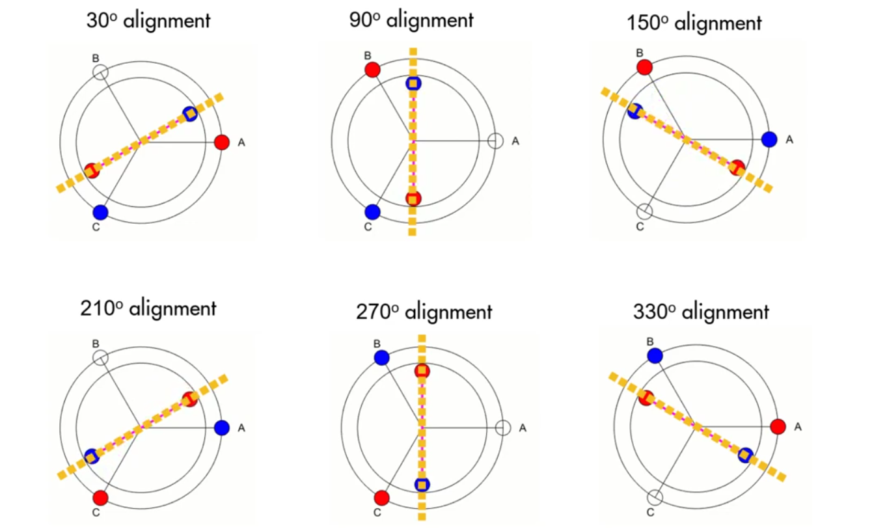

Figure 4: Possible ways of energizing coil pairs

**| CH1 | System Overview**

**How the poles interact with each other?**

These two poles of the same kind repel each other making the rotor turn counterclockwise at the same time the opposite poles attract each other and the rotor keeps on turning in the same direction

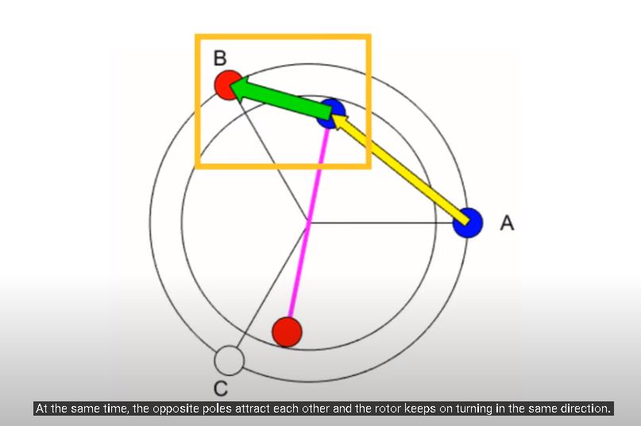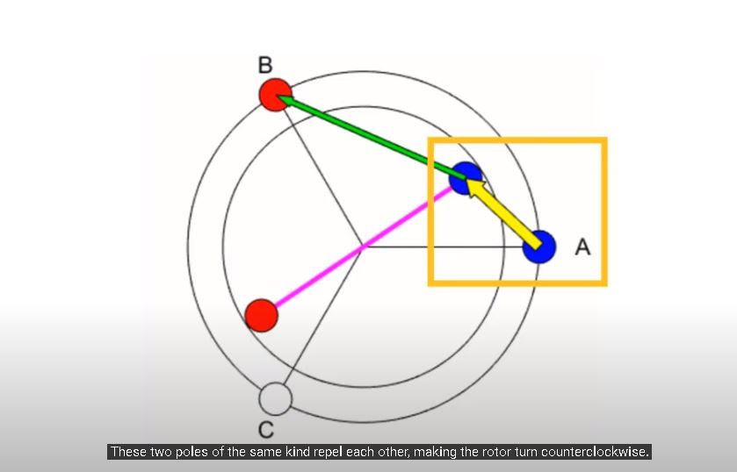

Figure 5: Interaction of the Poles

Once it complete 60-degrees of rotation the next commutation occurs.

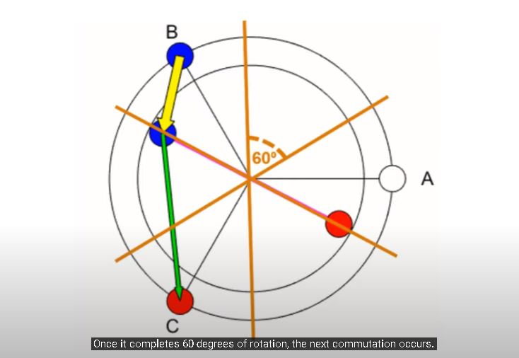

Figure 6: interaction of Poles every 60-degrees

**| CH1 | System Overview**

The commutation occurs in such a way that the rotor never aligns with the stator magnetic field but it always chasing it, there are two facts that can explain this behavior:

1. When the rotor and stator magnetic fields align perfectly the motor creates zero torque so, we never let them align.

2. The maximum torque occurs when the fields are at 90- degrees to each other.

So, the goal is to bring this angle close to 90-degrees. However, in BLDC motors we never achieve 90- degrees with six step commutation. But the angle fluctuates within some range and this is due to the simple nature of trapezoidal control.

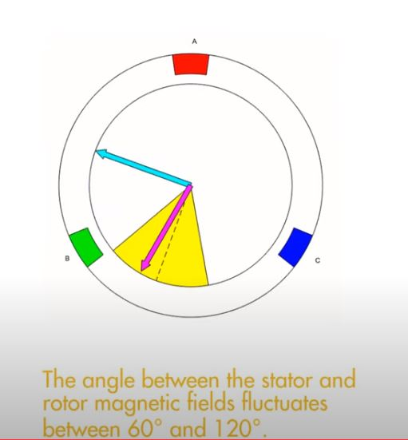

Figure 7: the angle between the stator and rotor magnetic fields fluctuates between [60-120] degrees

but more advanced techniques such as field-oriented control (FOC) allows to generate a large torque by achieving 90-degrees between the stator and the rotor magnetic fields

**| CH2 | Inverter Design**

**CHAPTER 2 || INVERTER DESGIN**

**2.1 Hardware Design**

Component Sizing:   
• ARM-based MC is selected for control circuit to Drive the inverter.  
• MOSFET is selected to be the power switching device in the inverter, because it is preferred for wide load or line variations, low voltage (less than 250V), large duty cycles and high frequency (more than 200KHZ) applications. [IRFP064NPBF, 𝑉𝐷𝑆𝑆 =55𝑉 𝑅𝐷𝑆(𝑜𝑛) = 0.008, 𝐼𝐷 = 110𝐴].  
• Opto-Coupler is selected to be the gate driver of the MOSFET, because it provides isolation between control input signals and the power circuit and it makes also signal conditioning because the output of the MC is 3.3V, so TLP250 rise it to 12V to turn on the gate of the MOSFET [Input threshold current: IF=5mA(max.), Supply current (ICC): 11mA(max.), Supply voltage (VCC): 10-35V, Output current (IO): ±1.5A (max.)].  
• 50-ohm Gate resistance is selected to damp the oscillation in the 𝑉𝑔𝑠 signal.

• Gate diode to decrease the falling time of the 𝑉𝑔𝑠 signal. [ 1n4007, 𝐼𝑎𝑣 = 1𝐴, 𝑉𝑑𝑐 = 35𝑣 ].  
• Fast Recovery Diode to decrease reverse recovery time [ BYW29-200, 𝐼𝑎𝑣 = 8𝐴, 𝑉𝑑𝑐 =200𝑣, 𝑟𝑒𝑐𝑜𝑣𝑒𝑟𝑦 𝑡𝑖𝑚𝑒 = 60 𝑛𝑠].

**| CH2 | Inverter Design**

**2.2 Schematic Overview**

We used Easy EDA for design PCB schematic and PCB.

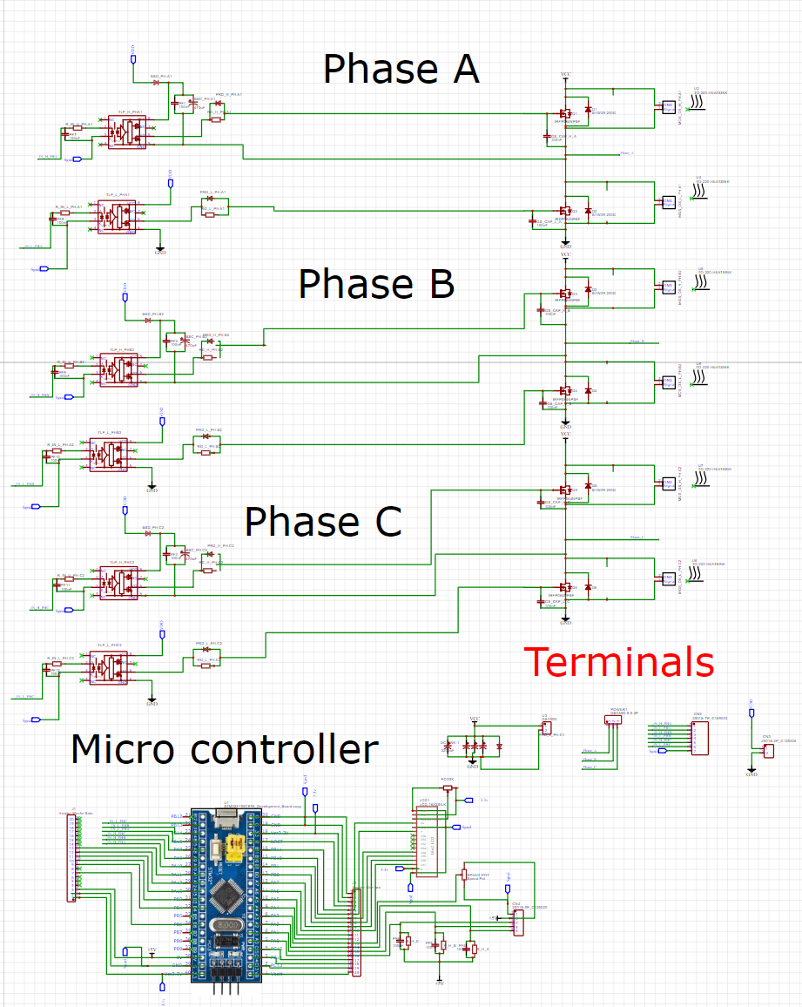

Figure 9: Schematic Overview

**| CH2 | Inverter Design**

**Schematic Building Blocks**

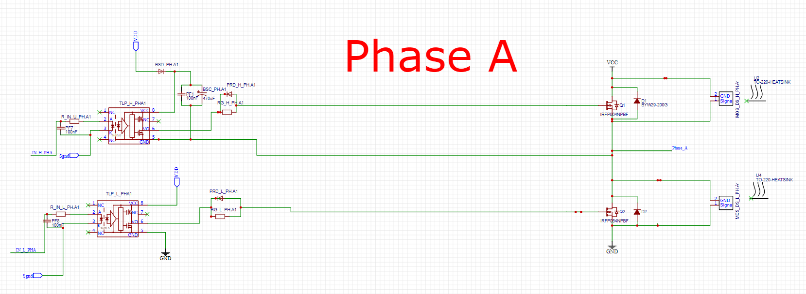 **1 – Inverter Phase Block**

Figure 10: Inverter phase block

**2 – Microcontroller**

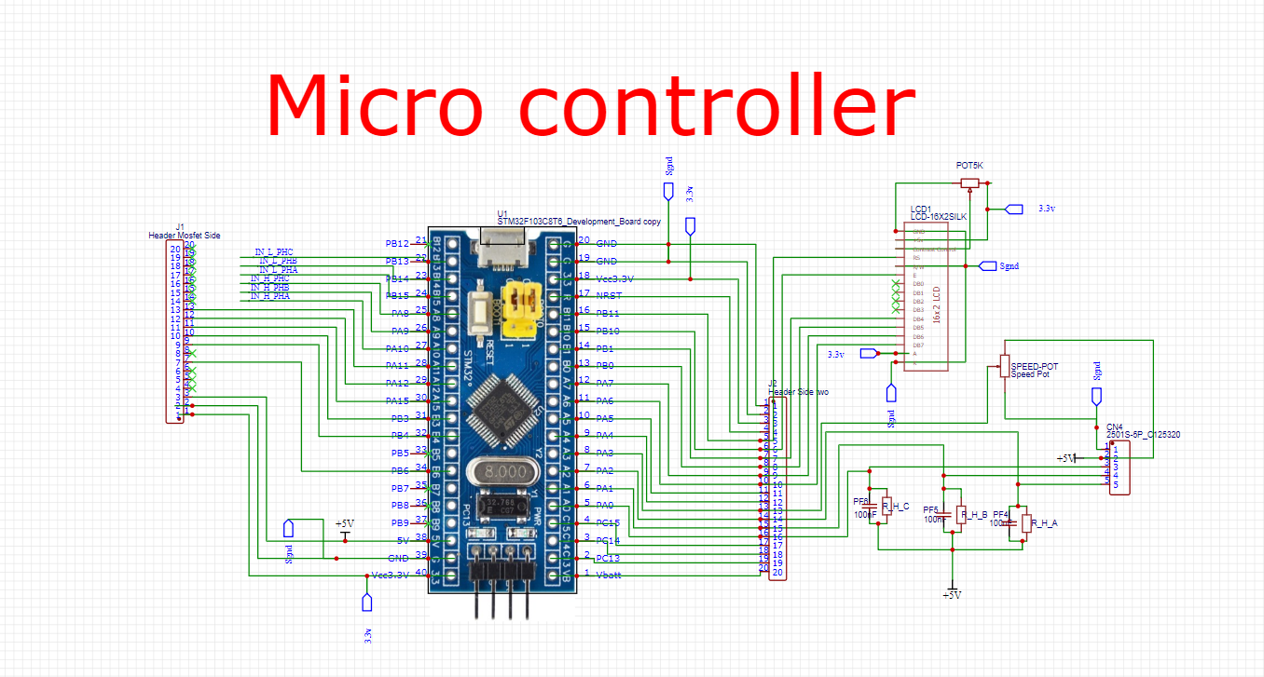

Figure 11: Inverter Controller

**| CH2 | Inverter Design**

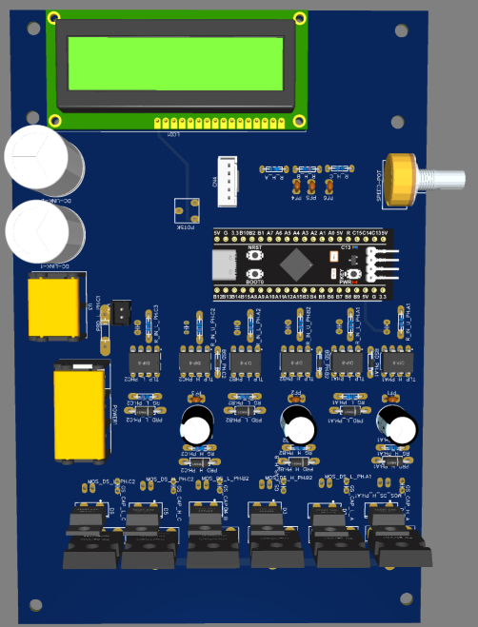 **2.3 PCB Design** **Overview**

Figure 12: Inverter PCB

**| CH2 | Inverter Design**

**2.4 Hardware Testing**

Inverter Output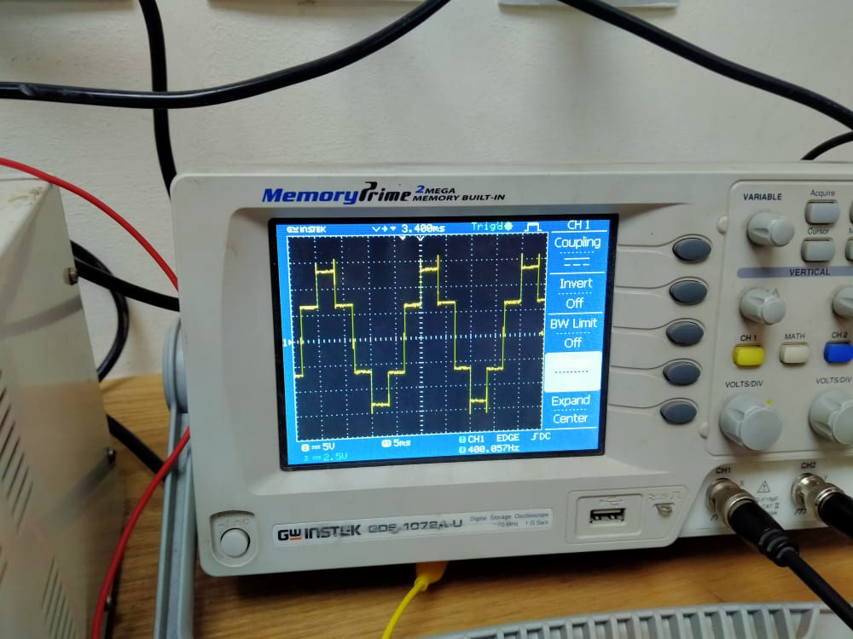

**2.3 Snubber Design**

Figure 13: no load inverter output

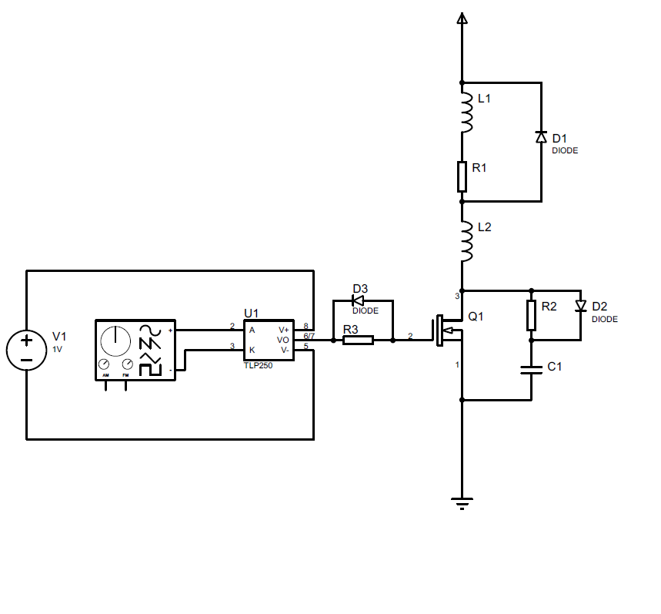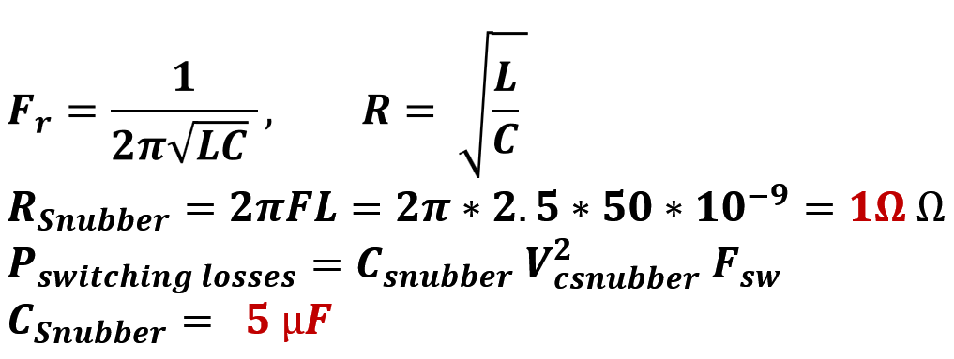

Figure 14: Snubber Design

**Inverter output after Snubber**

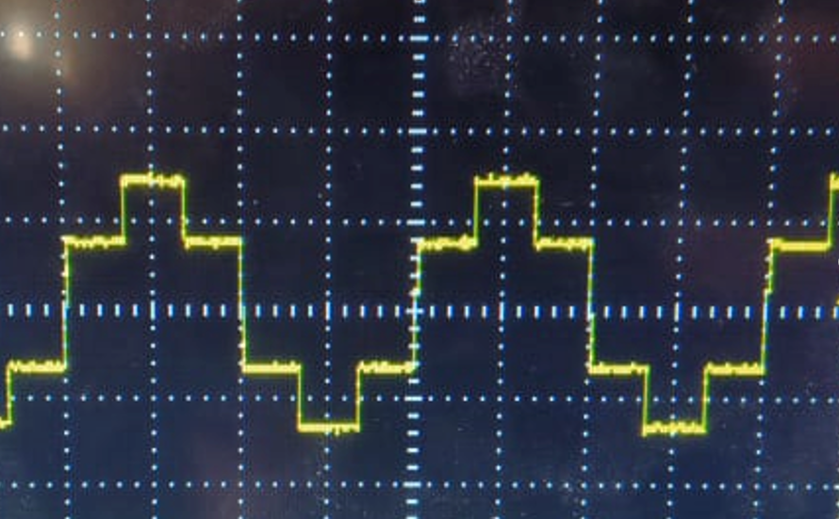

voltage with Inductive load with Snubber Circuit [R = 35Ω, L = 1.5 mH].

Figure 15: inverter output with Inductive load with Snubber

**| CH2 | Inverter Design**

**2.4 Testing Inverter with Motor**

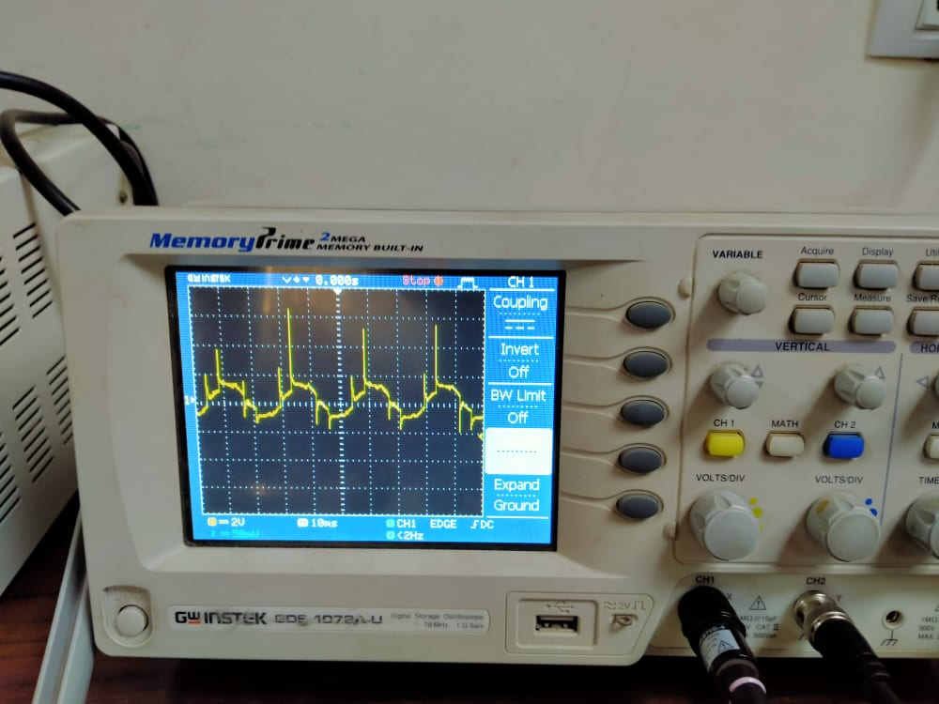

Figure 16: Motor line voltage

**| CH3 | Speed Control**

**CHAPTER 3 || SPEED CONTROL**

**3.1 Open loop Motor Performance**

In this MATLAB model we try to simulate motor performance at several operating conditions we will go through into each block to explain it.

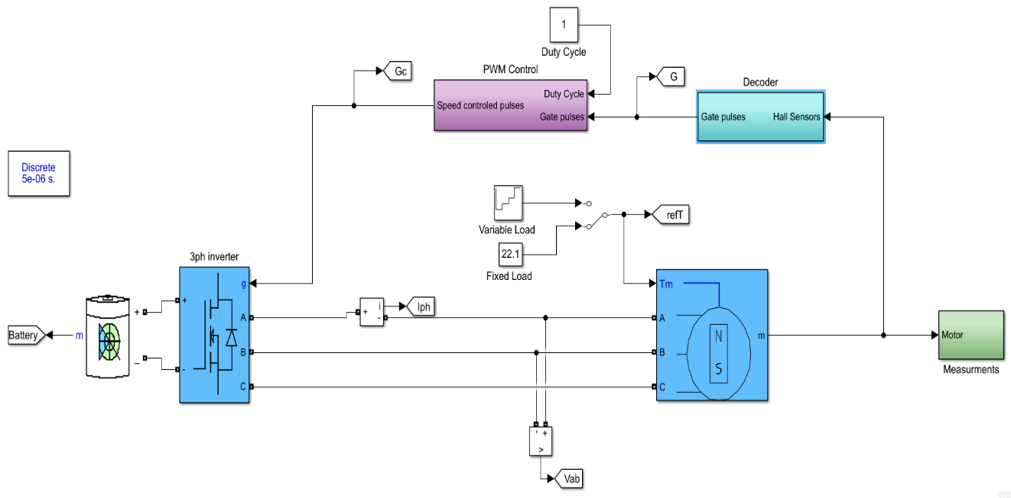

Figure 17: open loop block diagram

We use six-step algorithm to drive our motor in open loop condition without speed or current feedback None of the coils energized so the rotor is stationery

Applying voltage across any two phases generates a combined magnetic field as a result of this, the rotor starts to rotate to align itself with stator magnetic field

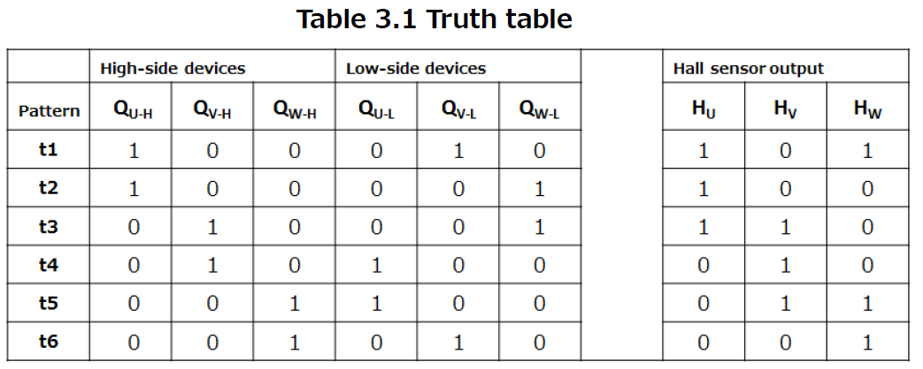There are 6 possible ways to energize phases and if we can commutate the correct phases every 60 degree, we can make the rotor spin

**| CH3 | Speed Control**

Hall sensors is used to detect the rotor position in order to commutate the correct phases to keep rotor spinning based on this lookup table.

**We implemented this logic in MATLAB Simulink environment ​**

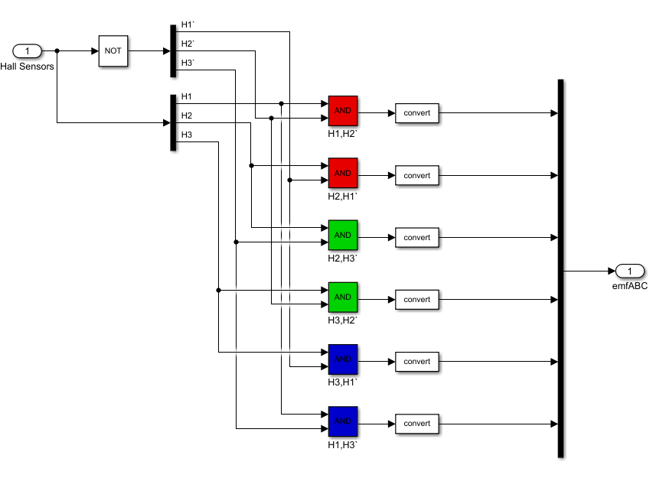

Figure 17: Hall Sensor Logic

**3.2.2 open loop speed control**

We can use gate pulses generated based on six step commutation to control the speed of the motor by applying any PWM techniques.  In our model we use method based on triangular wave form compared with reference voltage

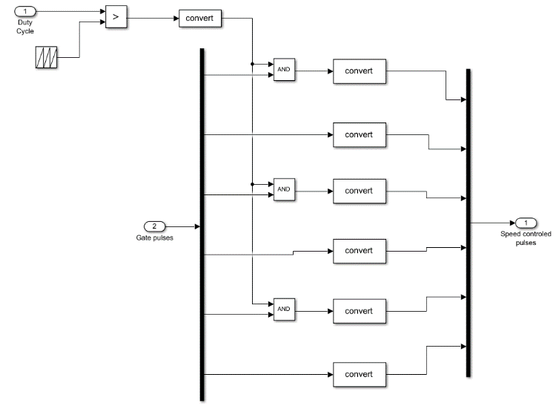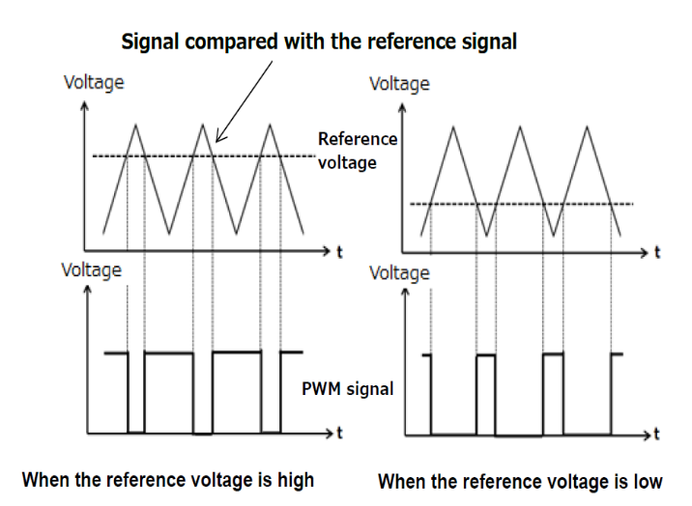

Figure 18: PWM Logic

**| CH3 | Speed Control**

In our model we used non complementary switching method which means that PWM can be applied on gate pulses of high side MOSFETS.

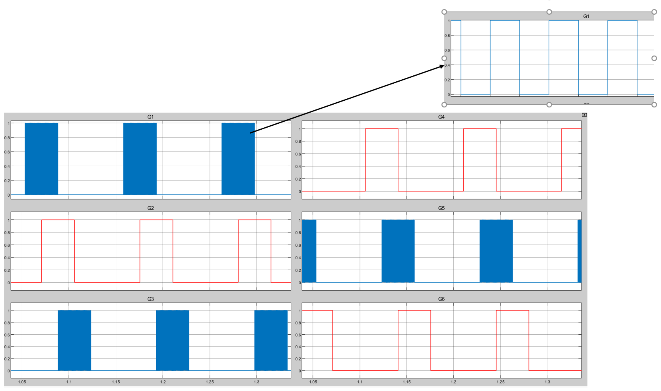

**Gate pulses with Duty cycle = 50%**

Figure 19: PWM output at Simulink

**3.2.3 Motor back EMF**

Back-EMF is t voltage produced by electromagnetic induction when a magnetic field from a magnet passes (rotates) through a coil that is conducting current and the following equation represents the relationship between the externally applied voltage and the back-EMF voltage.

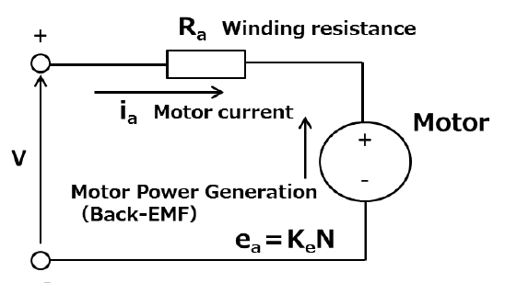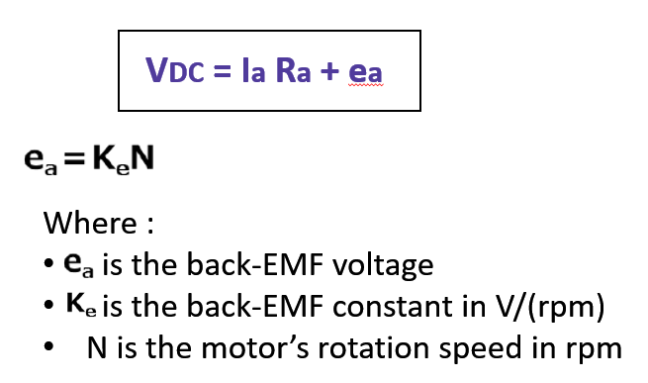

**| CH3 | Speed Control**

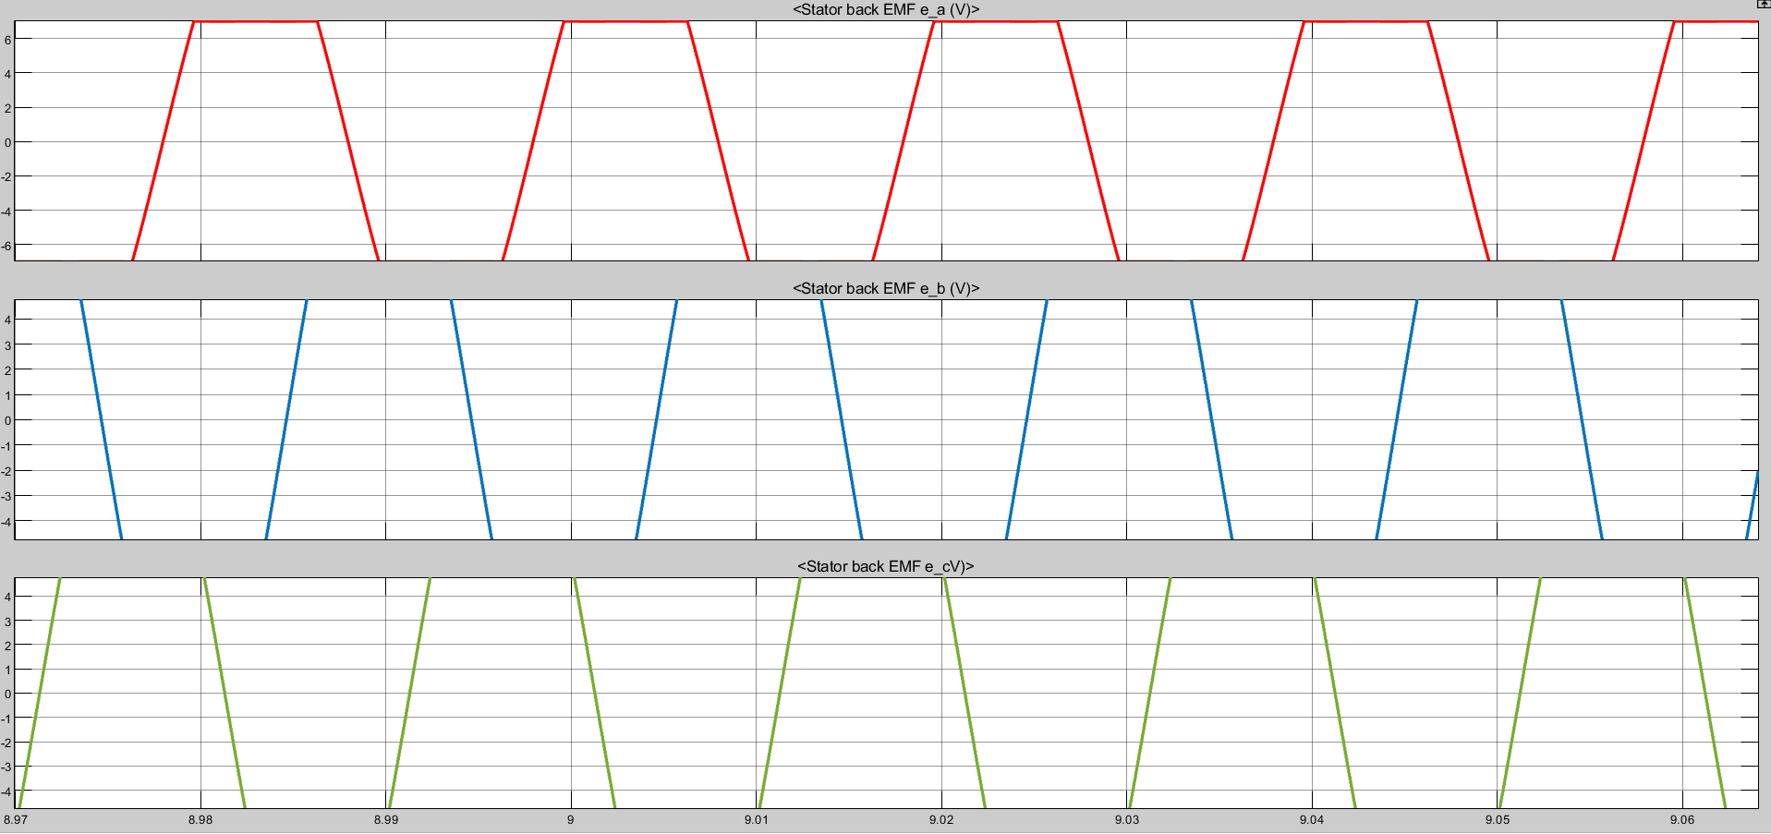**Back EMF wave form**

Figure 20: Motor Back EMF

**Inverter output voltage and current waveform**

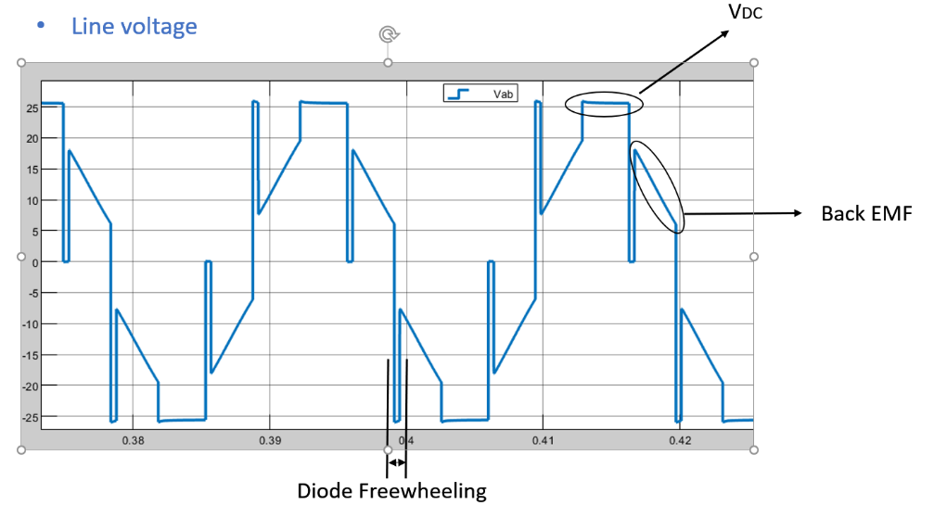

Figure 21: Inverter output with motor connected

During the commutation, each switch becomes off after 120 electrical degrees a current flowback through the body diode in switch until the energy stored in phase winding .5LI^2 disappears, after that the terminal voltage becomes equal to the back-EMF voltage.

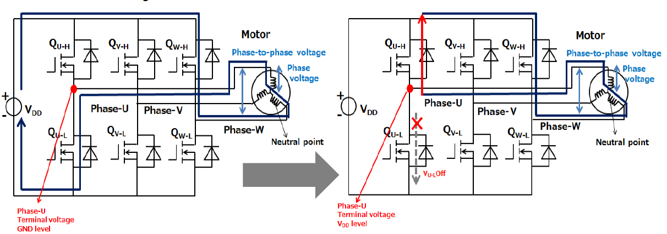

**| CH3 | Speed Control**

**Motor performance**



Figure 22: Motor Performance

**3.3.4 Torque ripples**

The gross output torque from BLDC motors and PMSMs is the sum of beneficial electromagnetic torque (steady torque) and unwanted torque or torque ripple produced by:

* Commutation
* DC bus ripple
* cogging torque friction

**Commutation /electromagnetic torque ripple in BLDC motors**

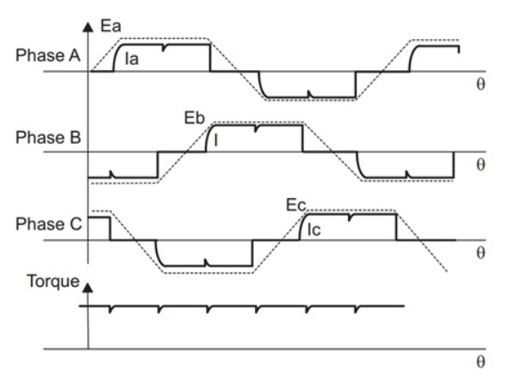If we assume an ideal square-current waveform applied to the winding, the torque generated will be constant without any ripple

**In reality**, winding currents cannot rise or fall instantaneously because of the winding inductance.

This causes torque ripple during the commutation of BLDC motor phase currents as shown in Figure

Figure 23: BLDC Back EMF

**| CH3 | Speed Control**

Here shows three different cases depending on the current’s rising and falling rate of the commutating windings

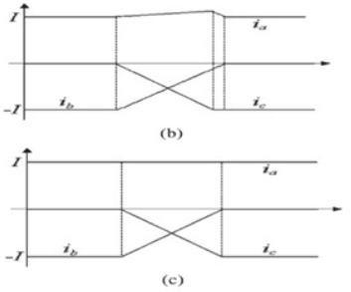

* **Case A**: the current increase and decrease rates of the two windings are the same as shown in Figure
* **Case B**: there is a mismatch in the current’s rising and falling rate of the commutating windings, which in turn causes commutation torque ripple

**Torque ripple due to DC-bus voltage ripple**

Bulk electrolytic capacitors are used on the high-voltage DC bus link of a mains-operated BLDC

The value of the capacitor for a given load decides the magnitude of ripple on the DC bus

A simple way to minimize torque ripple caused by DC-bus voltage ripple is to use a very-high-value DC bus capacitor this will increase overall size and system cost, as high-voltage capacitors are bulkier and take up a significant share of the bill of materials cost. A general thumb rule is to calculate the DC bus capacitor value to maintain DC-bus voltage ripple within **5-10%**, depending on the quality of performance required.

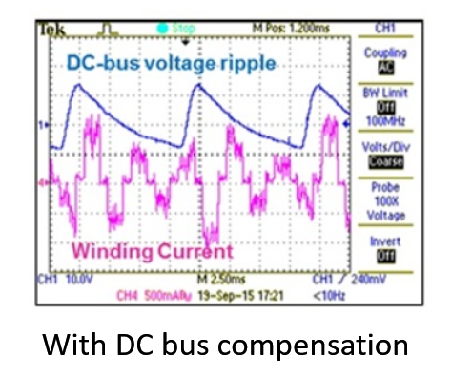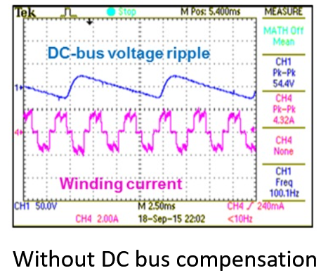

Figure 24: Comparison between DC bus with compensation and without

**| CH3 | Speed Control**

**3.3 Speed Measurements calculations**

* The six steps represent 360o electrical of the motor rotation
* The number of motor pole pairs 🡪 p = 20
* The six steps represent = 18o mech.
* The rotor will rotate = 3o mech. per sector (step).
* The motor speed = $\frac{3° * \frac{π}{180 } }{Time between two steps }*\frac{60}{2π }$ = $\frac{0.5 }{Time between two steps}$ (rpm)
* The time between two steps is obtained by XOR the three hall sensors signal then measuring the time between two changes using input capture unit in the micro controller.
* When the BLDC motor rotates at 150 rpm, the outputs of the hall sensors and the XORing between them are shown in figure



Figure 25: Speed Measurments

$Time between two steps$*= $\frac{0.5 }{150 rpm}$ = 3.33msec*

**| CH3 | Speed Control**

**3.4 Closed-loop model (speed controller design)**

To design a controller for any system, the transfer function of the system must be obtained properly.

**T.F. for BLDC motor**After reading a considerable number of papers and researches, we can conclude that the T.F. for BLDC motor can be derived from two models.

1. Consider the BLDC motor as a DC motor but with three phases.
2. Consider that for any operating point (any sector) the BLDC motor is a two-phase DC motor as for any sector, there is only two phases are energized.

We found that the second model is more realistic and describes the operation of the BLDC motor properly, so we decided to work on it as follows.

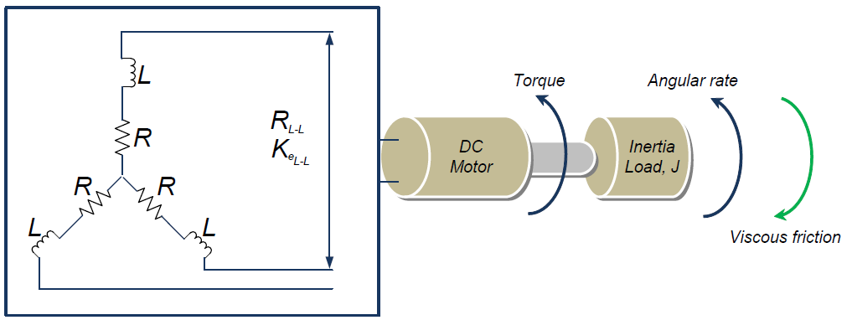**Mathematical model for BLDC**

**At any sector (only two phases are energized)**

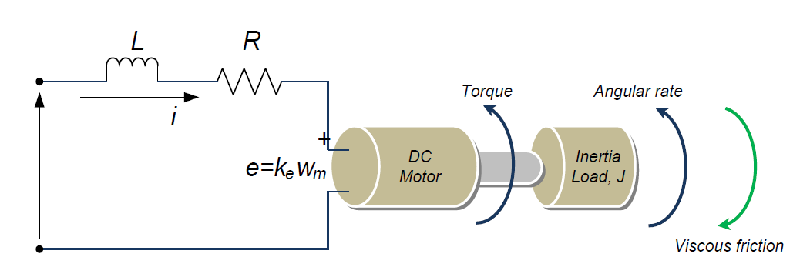

Vs

2

2

2

$$V_{DC}$$

Figure 26: BLDC Model

**| CH3 | Speed Control**

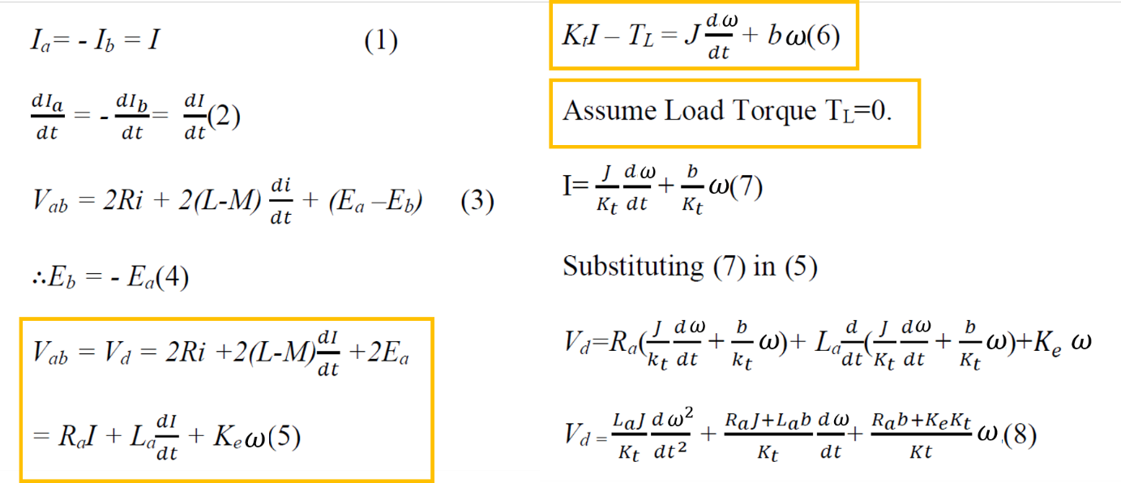Depending on Kirchhoff's voltage law and torque equation

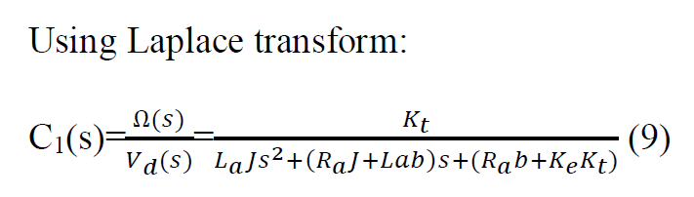

$$G\left(S\right)=\frac{ω(S)}{V_{d}(S)}=$$

$$G\left(S\right)=\frac{ω(S)}{V_{d}(S)}=\frac{\frac{1}{k_{e}}}{τ_{m}τ_{e}S^{2}+τ_{m}S+1}$$

$k_{e}^{`}$*is L-L voltage constant*

$$k_{e}=2k_{e}^{`}$$

$R$*is per-phase resistance*

$L$*is per-phase inductance*

$$L_{a}=2L$$

$$R_{a}=2R$$

$$k_{t}=2k_{e}$$

$$k_{e}=\frac{1}{2}k_{t}$$

$$\frac{E}{ω}=\frac{T}{2I}$$

$$2E×I=ω×T$$

**Assume**

**| CH3 | Speed Control**

|  |  |
| --- | --- |
| **Parameter** | **Value** |
| Armature per-phase resistance, $R_{a}$ | $$0.25 Ω$$ |
| Armature per-phase inductance, $L_{a}$ | $$250 µH$$ |
| Back emf constant, $Ke$ (L-L) | $$0.315 V.s/rad$$ |
| Torque constant, $K_{t}=2K_{e}$ | $$0.63 N.m/A$$ |
| Viscous friction coefficient, $B$ | $$0$$ |
| Rotor moment of inertia, $J$ | Rotor radius: $9 cm$ Wheel radius: $33 cm$ Motor weight: $3 Kg$ Wheel weight: $2 Kg$ $$Jtot = Jmotor + Jwheel + Jspokes$$ $$= 0.5 * 3 *0.332 + 2 * 0.092 ≅ 0.2 kg.m2$$ |
| No. of poles, $2P$ | $$40$$ |
| No. of phases, $m$ | $$3$$ |
| Rated DC voltage $V_{DC}$ | $$36 V$$ |
| Rated synchronous speed, $n_{s}$ | $$900 rpm$$ |
| Rated power, $P_{r}$ | $$330 W$$ |

It’s obvious that the motor parameters are needed to be able to calculate the T.F.

* value of back EMF constant $K_{e}$ was obtained in the lab; by rotating the motor at a certain speed then measuring the voltage between two phases, changing the speed then measuring the voltage again and so on. After a number of measurements, $K_{e}$ can be calculated from $E=K_{e}×ω$
* No. of poles $2P$ can be obtained by injecting small DC current on two phases then rotating the motor slowly and counting the number of positions that the motor stops at.
* $V_{DC} , n_{s} , P_{r}$ are from the nameplate of the inverter found in the lab.

**| CH3 | Speed Control**

After substitution in the previous T.F. formula

$$G\left(S\right)=\frac{1.587}{252×{10}^{-6} S^{2}+0.252S+1}$$

It can be concluded that the motor system has two poles (-1000 and -3.97) which are the electrical and mechanical pole respectively. The electrical pole is very far from the origin, very fast that it can be neglected compared to the mechanical pole which is the dominant.   
So that, and for simplicity, we can consider the model as a first order system with one pole at -4.

$$G_{M}\left(S\right)=\frac{1.587}{0.252S+1}$$

$$G_{M}\left(S\right)=\frac{1.587}{\frac{S}{\frac{1}{0.252}}+1}$$

$$ω_{M}=3.97≈4 rad/s$$

$$G_{M}=1.587$$

$$f_{M}=0.63 Hz$$

After deriving the T.F for BLDC motor we can conclude the block diagram for the whole system as follows.

Inverter Gain

$$D$$

$$V_{DC}^{`}$$

$$-$$

$$G_{phy}(S)$$

Now the question is how to determine the value of inverter gain ?

**| CH3 | Speed Control**

**Inverter gain**  
To answer that question, we can consider any sector as follows (for a resistive load for simplicity). Consider a sector with one upper side and one lower side MOSFETs; S1 and S6 are on with PWM with certain duty D on S1. Compare between the output line voltage for D=1 (no PWM) and with D=0.5.

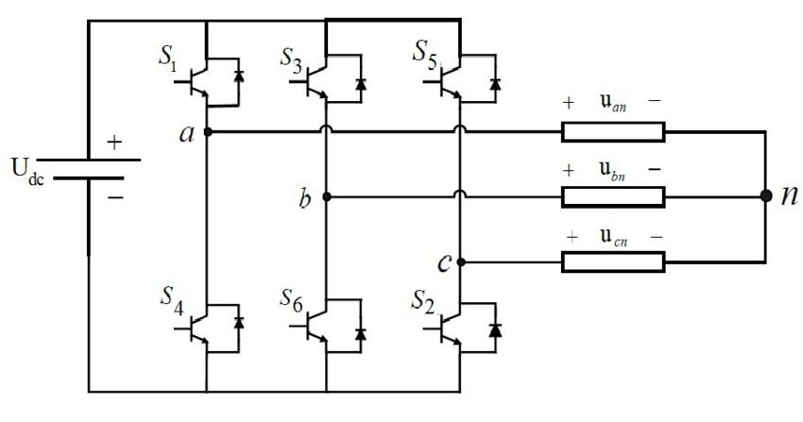

$$PWM$$

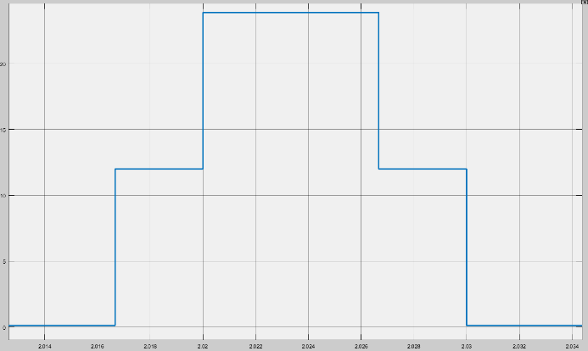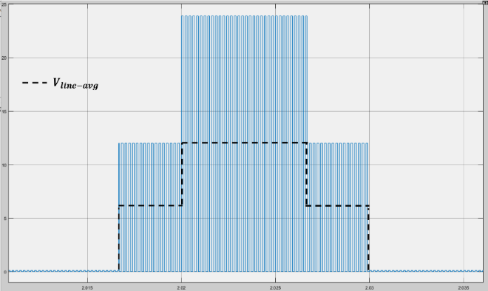

$$D=1$$

$$D=0.5$$

And by neglecting periods of zero output, we can assume the average line voltage is the DC voltage multiplying by the value of the duty cycle D.

$$V_{line-avg}{=V}_{DC}^{`}=D×V_{DC}$$

$$=\frac{V_{DC}^{`}}{D}=V_{DC}=36$$

Inverter Gain $K_{inv}$

At one sector

**| CH3 | Speed Control**

The block diagram of the system now can be concluded as follows

**Controller design**to design a controller we build a MATLAB Simulink model as follows.

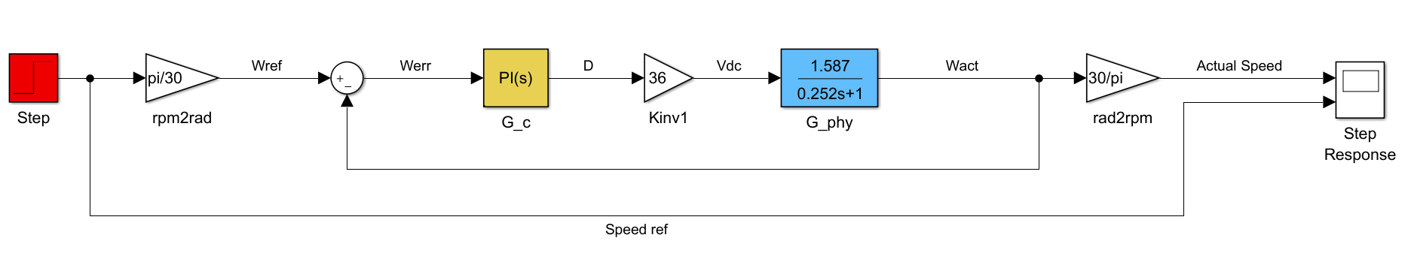

We designed our controller to achieve these requirement

**Make low-frequency gain very large**

* To minimize steady-state error

Step input, Type 0 system

$$→ e_{ss}≠0$$

**Make cross-over frequency $f_{c}$ as high as possible**

* To maximize closed-loop bandwidth.
* For the system to response to wider range of frequencies.

$$f_{sw}=5 kHz →$$

Choose $f_{c}$ way lower than $f_{sw}$

as we consider the inverter as a DC gain.

Choose $f_{c}$ way higher than $f_{phy}$

to maximize closed-loop bandwidth.

**| CH3 | Speed Control**

**Choose $f_{c}=50 Hz$**

**Maintain large enough phase margin $φ_{m}$**

* Phase margin > 0 is required for stability.
* Larger phase margin is required for well-behaved closed-loop response.

**Choose $φ_{m}≥90°$**

**Proportional controller (P)**

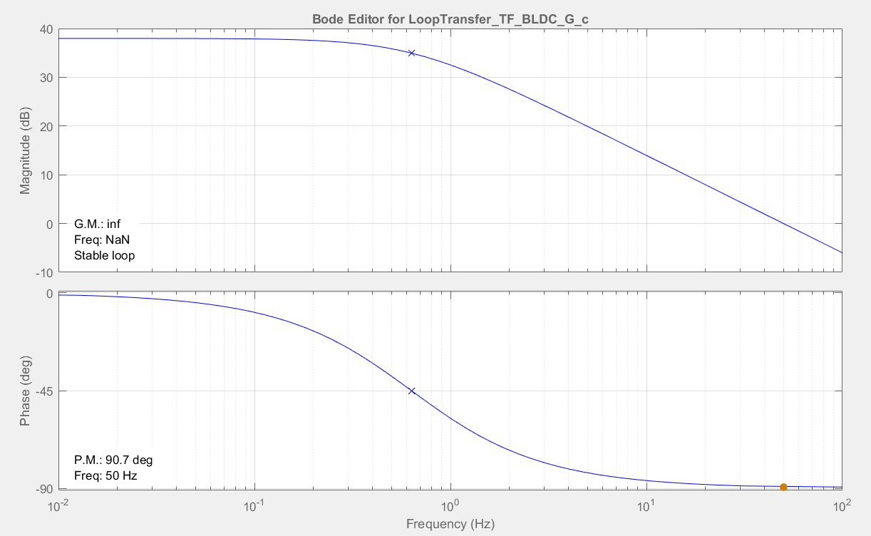

**For $f_{c}=50 Hz$**

$$G_{cm}=1.4$$

$$\left\|T(s)\right\|=38 dB$$

$φ_{m}=90°$

Figure 27: Motor Performance

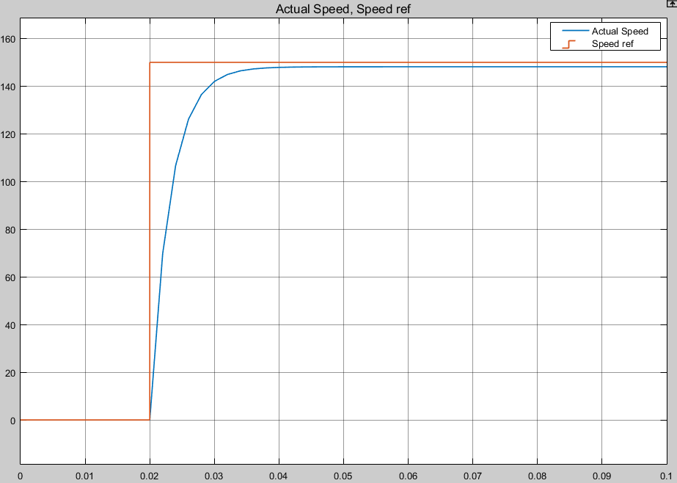

Steady State Value $=148$

Steady State Error $e_{ss}$ $=1.3\%$

Settling time $T_{s}$ $=16 msec$

**Step response** We noticed the following.

* For a step reference speed of $150 rpm$ the steady state value was $148 rpm$.
* That means a steady state error of $1.3\%$.
* A settling time about $16 msec$ which seems very short for a real motor but it can be acceptable as the assumptions made on this model.
* No over shoot.

Figure 28: Motor SS Error and Settling time

**| CH3 | Speed Control**

**Proportional tegral controller (PI)**

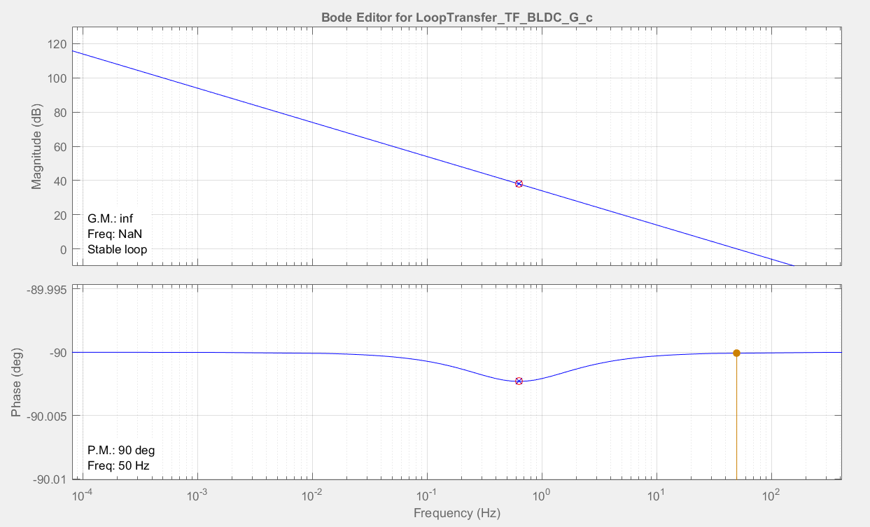

**Is high at low frequency**

$$f_{c}=50 Hz$$

$φ_{m}=90°$

$$G_{cm}=1.4$$

By adding an integrator (pole at origin), and a real zero at -4

$$\left\|T(s)\right\|$$

**For $φ_{m}=90°$**

$$G_{c}\left(S\right)=G_{cm}\left(1+\frac{ω_{z}}{S}\right)$$

$$ω_{z}=ω_{phy}=4 rad/s$$

**Is high at low frequency**

**Step response**We noticed the following.

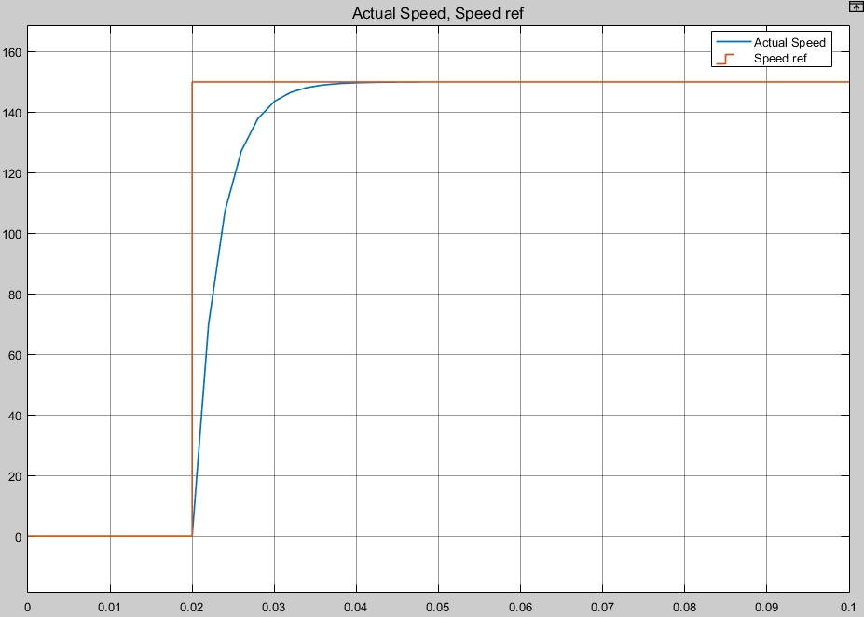

Steady State Value $=150$

Steady State Error $e_{ss}$ $=0\%$

Settling time $T_{s}$ $=13 msec$

* For a step reference speed of $150 rpm$ the steady state value was $150 rpm$.
* That means there is no steady state error as expected.
* A settling time about $13 msec$ which doesn’t differ a lot from P controller.
* No over shoot.

**| CH3 | Speed Control**

**Evaluating the controller performance on the motor model**

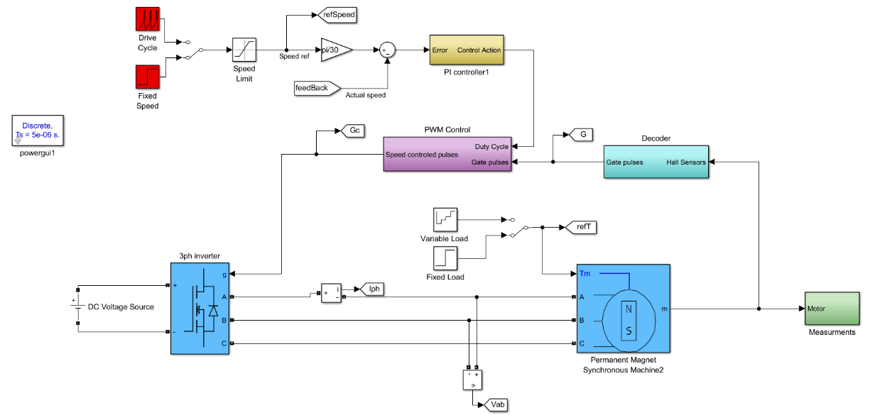

Figure 29: PI Controller

For a step speed reference of $150 rpm$ and a fixed load torque of $1 N.m$

We noticed the following.

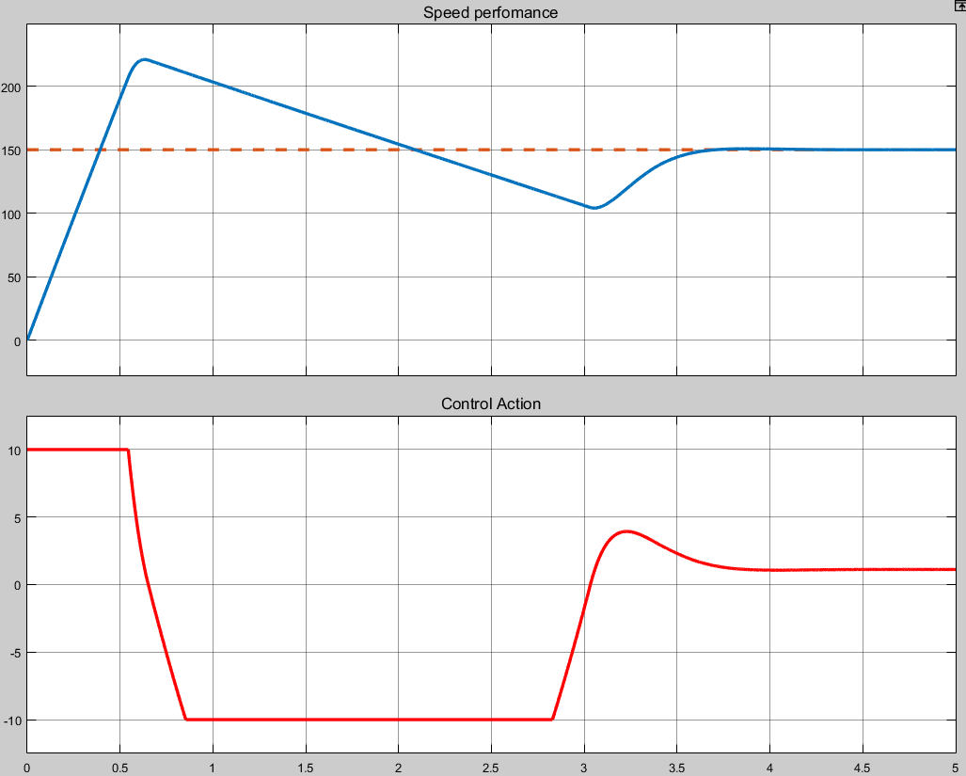

* High overshoot $O.S.≅53\%$ Due to high control action which exceeds the maximum limitations of the capability of the motor (windup problem).
* Settling time $T_{s}=3.5 sec$ which is considerably high compared to the PI controller applied on the mathematical model.
* Steady state error $e_{ss}=0$

For a better performance, we applied a PI controller with anti-windup

**| CH3 | Speed Control**

**PI controller with Anti-Windup**

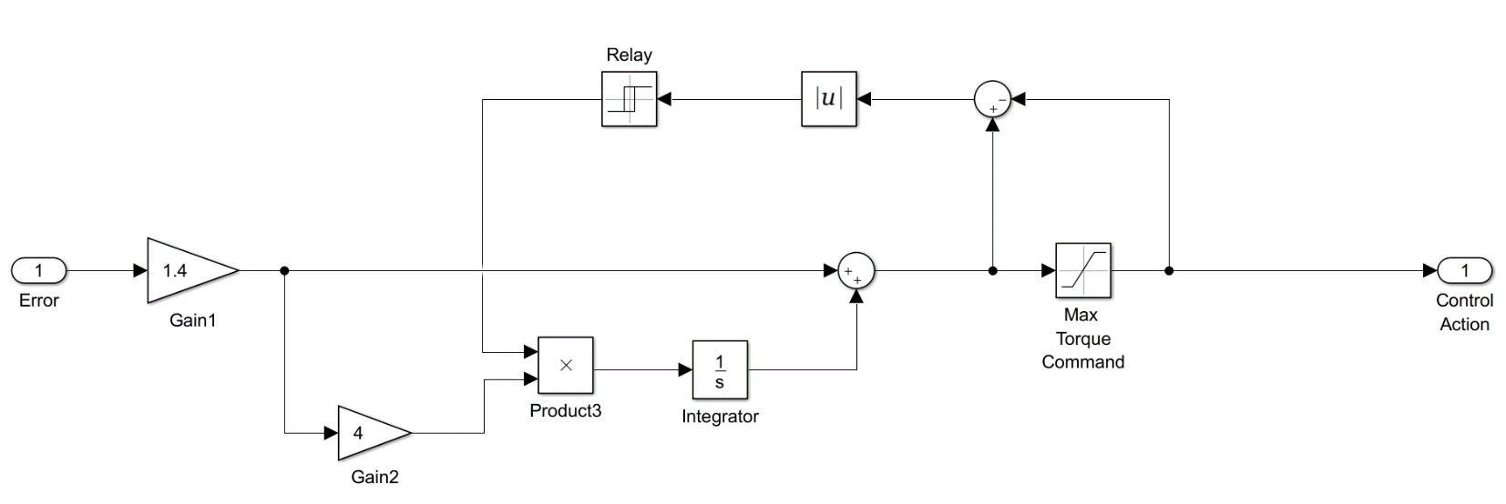

For a step speed reference of $150 rpm$ and a fixed load torque of $1 N.m$

We noticed the following.

* Much less overshoot $O.S.≅3.3\%$ as the integrator is set to zero when the control action exceeds the limitations.

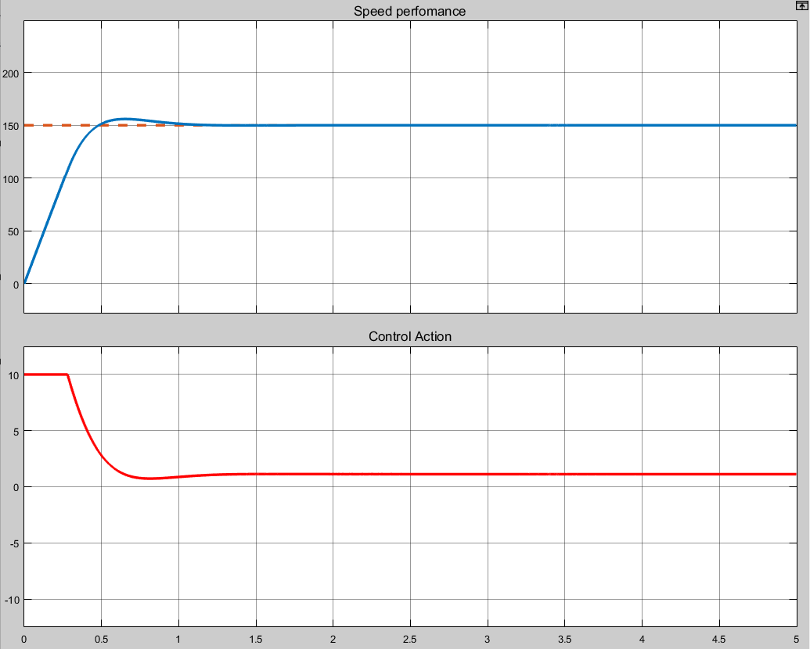

* Much less settling time compared to the case before applying the anti-windup $T_{s}=0.9 sec$ and it’s more realistic that it’s more time than that was in the mathematical model ($13 msec$). As this model contains more dynamics which is closer to the real motor.
* Steady state error

**| CH3 | Speed Control**

Performance Improvement of BLDC Motor with Hysteresis Current Controller

if the waveforms of the phase back EMF and phase current are perfectly matched, torque ripple is minimized. In this part, closed loop speed control is done by using PI controller and hysteresis current controller loop is added with speed feedback loop and it is observed that there is a reduction in the current ripple hence torque ripple is minimized.

# **model of BLDC motor drive with Hysteresis current controller loop**

Figure 30: Hysteresis current controller

• Reference current generator

* the output of the PI speed controller is the reference torque (𝑇𝑟𝑒𝑓).
* The magnitude of the three-phase current (𝑖𝑟𝑒𝑓) is determined by using the reference torque (𝑇𝑟𝑒𝑓) using 𝑖𝑟𝑒𝑓 = 𝑇𝑟𝑒𝑓 / 𝐾t.
* The reference currents for each phase $i_{a}^{*} ,i_{b}^{*}$, $i_{c}^{*}$ are function of the value of reference current magnitude 𝑖𝑟𝑒𝑓 and the rotor position as shown in figure.

**| CH3 | Speed Control**

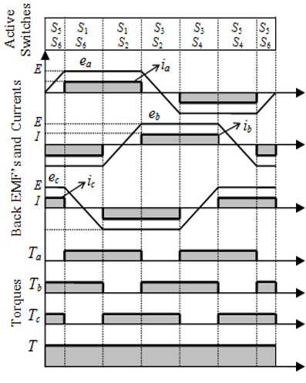

* Reference current w.r.t rotor positions look up table as shown in table
* **Reference current generator in Simulink**

Figure 31: Hysteresis current controller

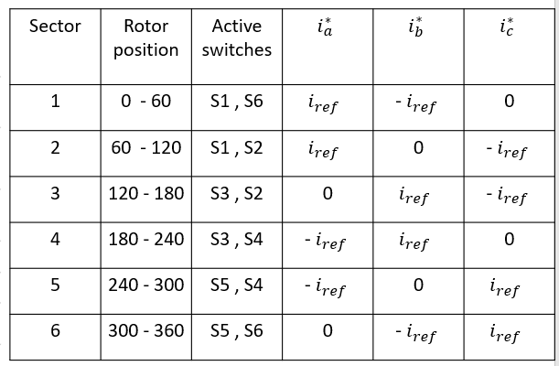

Figure 32: Hysteresis current controller

**| CH3 | Speed Control**

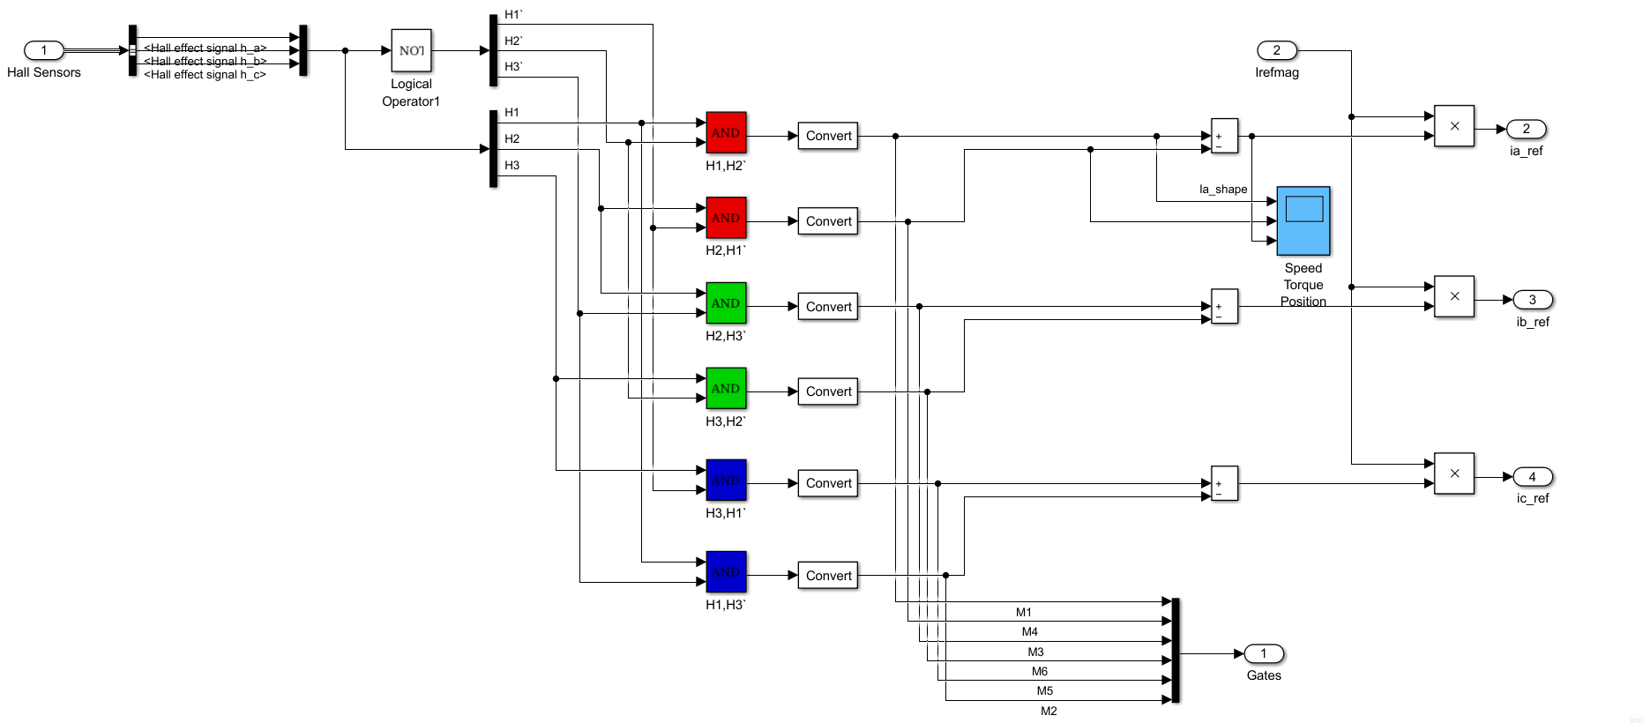

Figure 33: Hysteresis current controller

* **Reference current generator results**

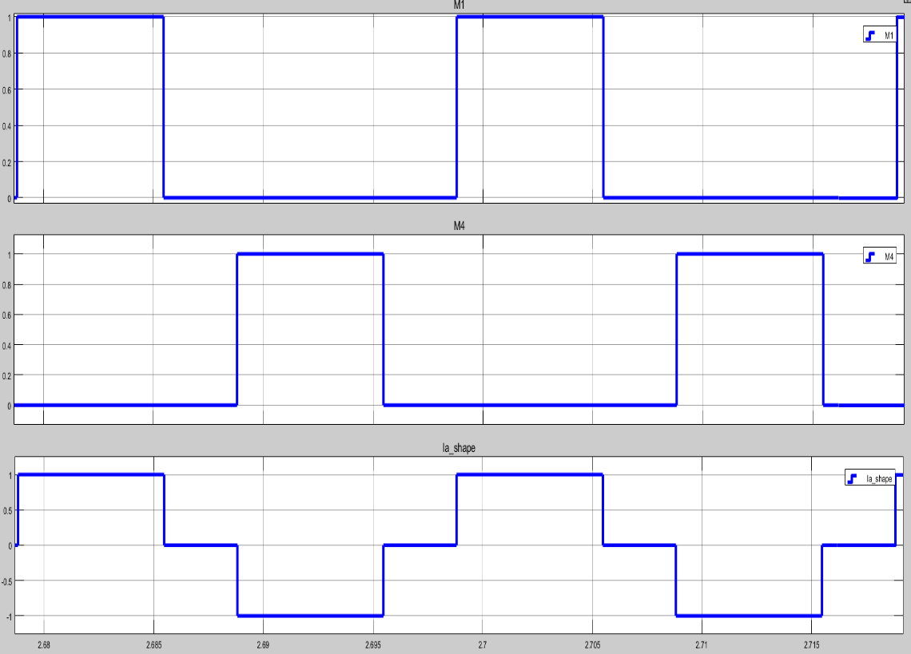

Figure 34: Hysteresis current controller

**| CH3 | Speed Control**

The shape of the reference current of phase A

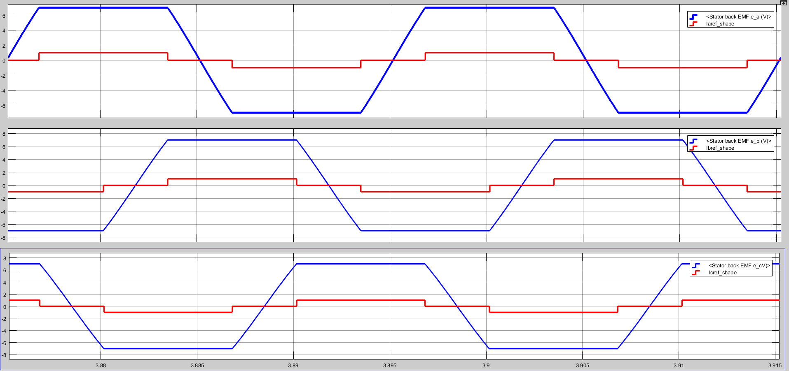

Figure 35: Hysteresis current controller

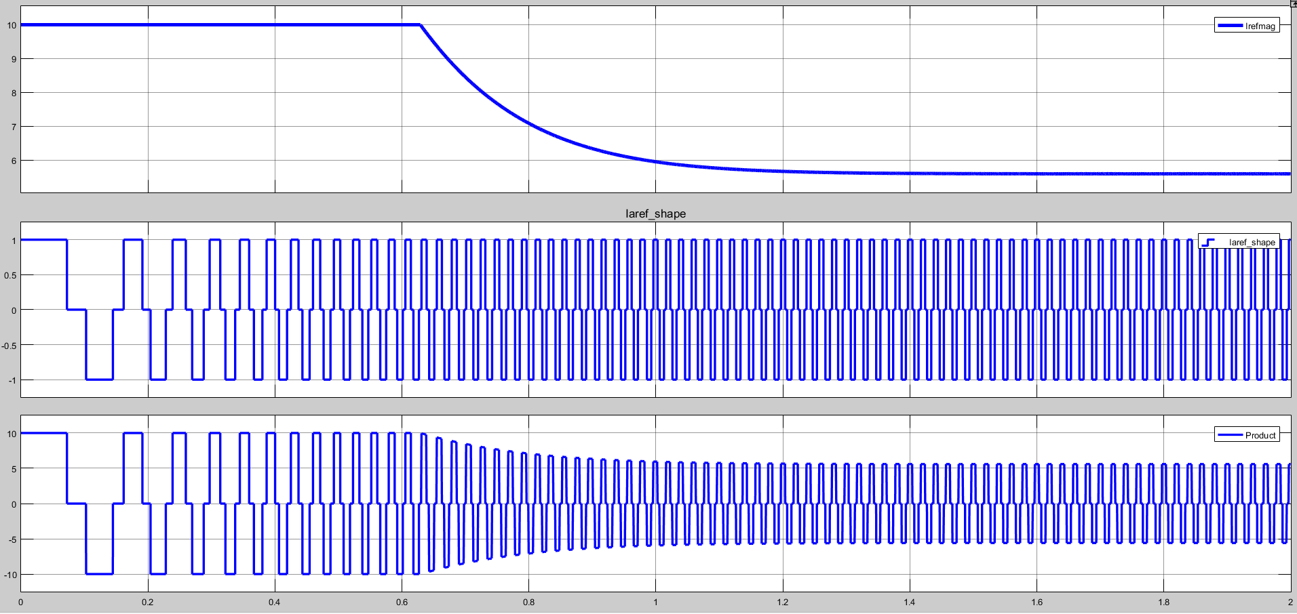**Back Emf ‘s and currents**

Figure 36: Hysteresis current controller

**| CH3 | Speed Control**

# **Hysteresis Current controller**

* The reference currents have the shape of quasi-square wave in phase with respective back EMF develops constant unidirectional torque.
* The input currents, ia, ib, ic are measured and compared with the reference currents, $i_{a}^{*}$, $i_{b }^{*}$, $i_{c}^{*}$. The error is fed to a comparator with a prescribed hysteresis band.
* The output of comparison between $i_{a} , i_{b}$, $i_{c}$ and $i_{a}^{*}$, $i_{b }^{*}$, $i_{c}^{*}$. is the switching commands to drive the inverter devices as shown in figure.

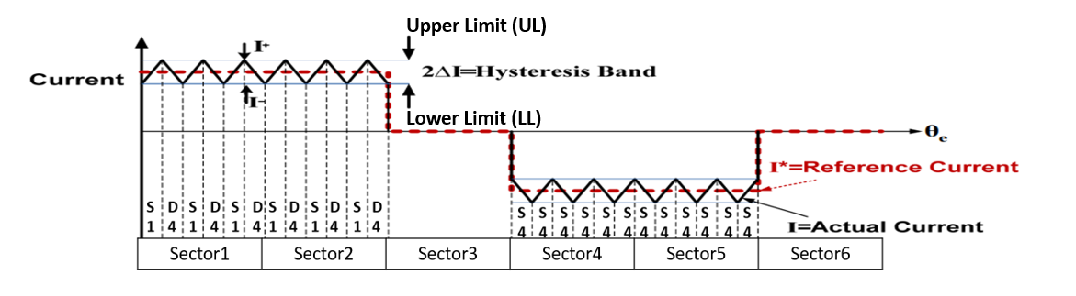

Figure 37: Hysteresis current controller

* When the current exceeds upper band limit, the upper switch is off.
* When the current exceeds lower band limit, the upper switch is on.
* The switching logic is formulated as given below.

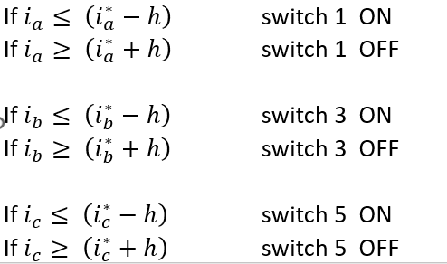

Figure 38: Hysteresis current controller

**| CH3 | Speed Control**

# **Comparison of BLDC drives with and without Hysteresis Current Controller**

* **Without Hysteresis current controller**
* Fig.8 shows that dynamic behavior of the motor when speed reference is set at 150 rpm. A current of 46.5 amps is observed at the time of starting while the motor is loaded by 1N.m.
* Fig.9 shows that a motor is developing a high torque of 41.5 Nm at the time of starting.
* **With Hysteresis current control loop**
* Fig.8 shows that dynamic behavior of the motor when speed reference is set at 150 rpm. A current of 10 amps (the limits according to the PI controller) is observed at the time of starting while the motor is loaded by 1N.m.
* Fig.9 shows that motor is developing torque of 8.5 N.m at the time of starting.
* the comparison between the magnitude of ripples variation in stator current with hysteresis current controller and without hysteresis current controller. It is observed that without hysteresis current controller the current ripples vary between ±2.5 amps, while with hysteresis current controller, the variation in the ripple is between ±1 amps.
* the comparison between the magnitude of ripples variation in the torque are less in hysteresis current controller when compared with without hysteresis current controller fed BLDC drive as current ripples decreases torque ripples are also minimized or reduced. It is observed that without hysteresis current controller the torque ripples vary between ±1 N.m, while with hysteresis current controller, the variation in the ripple is between ±2.5 N.m.

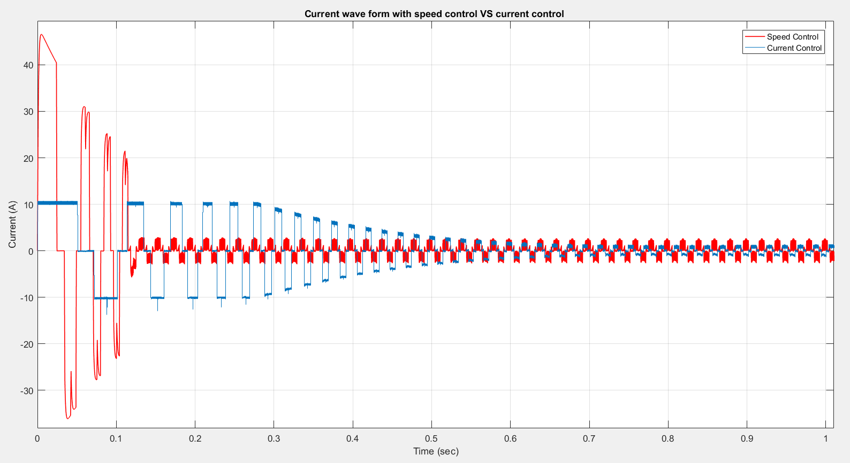

Figure 39: Hysteresis current controller

**| CH3 | Speed Control**

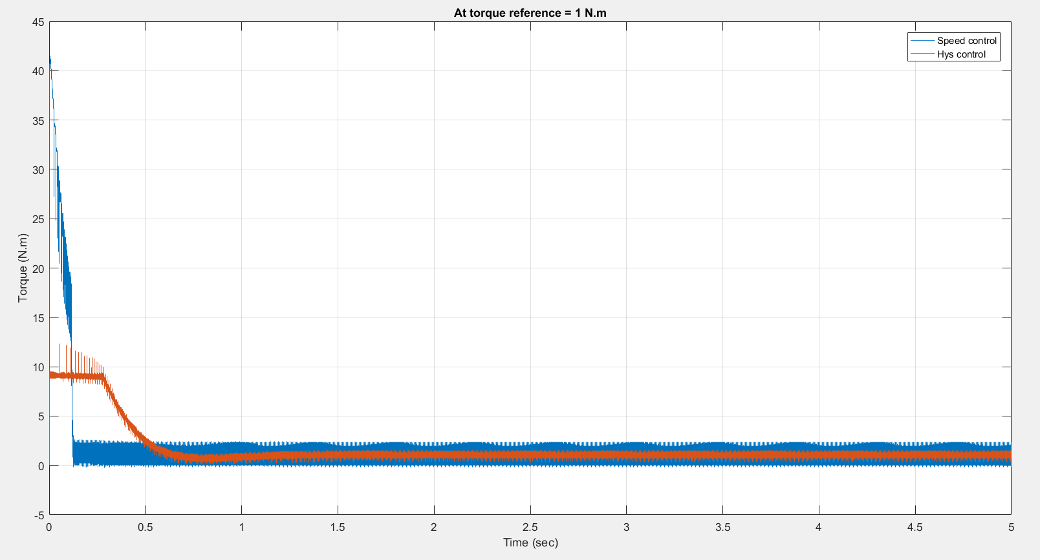**Current waveforms with and without hysteresis**

Figure 39: Hysteresis current controller

**torque waveforms with and without hysteresis**

# **Speed Performance at different load torques and at different reference speeds**

* **At different load torques**

The motor dynamic behavior is analyzed when different load torques is applied at time t = 2s for the same speed (150 rpm).

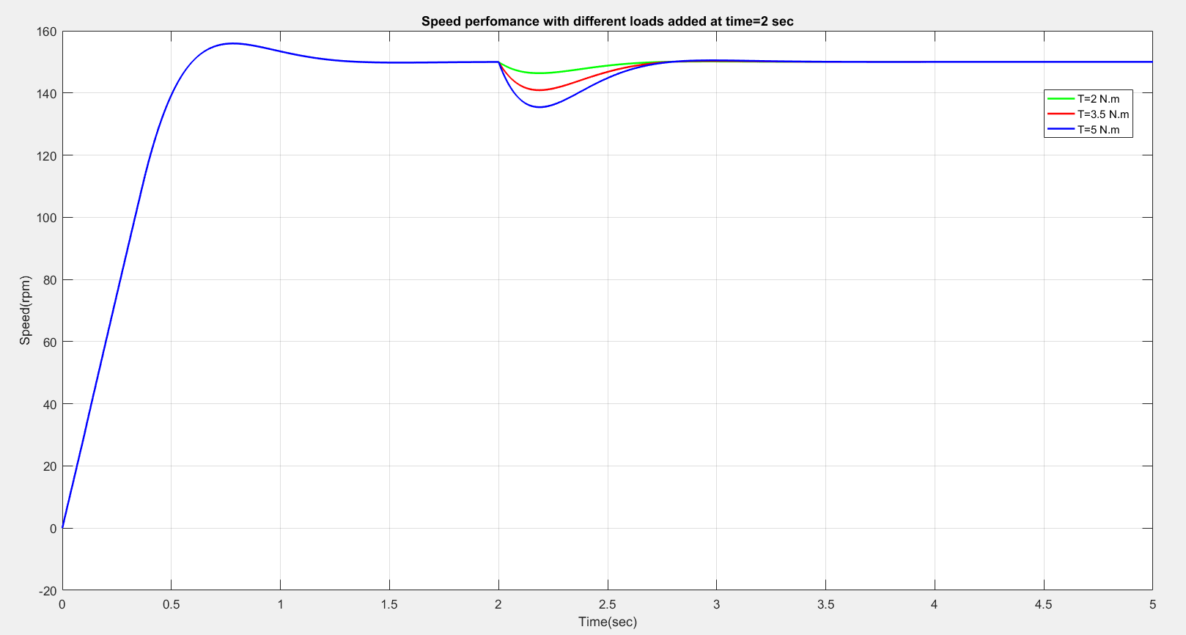

C1

C3

C2

Figure 40: Hysteresis current controller

**| CH3 | Speed Control**

|  |  |  |
| --- | --- | --- |
| Curve | Load torque (N.m) | Speed fall % |
| C1 | 2 | 2.7 |
| C2 | 3.5 | 6 |
| C3 | 5 | 9.3 |

Figure 41: Hysteresis current controller

* **At different reference speed**

The motor dynamic behavior is analyzed when same load torque (1N.m) is applied.

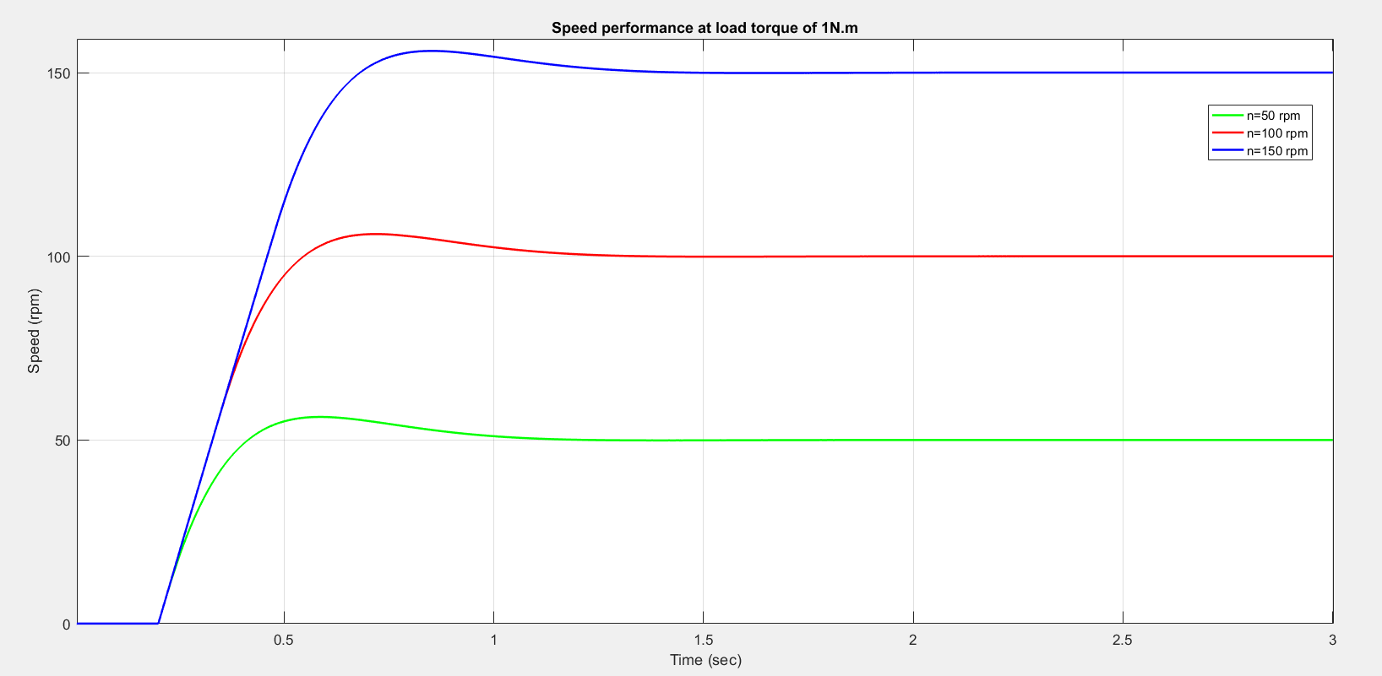

C2

C1

C3

Figure 42: Hysteresis current controller

|  |  |  |
| --- | --- | --- |
| Curve | Speed(rpm) | Settling time (sec) |
| C1 | 50 | 0.75 |
| C2 | 100 | 0.8 |
| C3 | 150 | 0.9 |

Figure 43: Hysteresis current controller

**| CH4 | Braking**

**CHAPTER 4 || BRAKING**

# **Introduction**

Brushless Direct current (BLDC) motors are one of the motor types rapidly gaining popularity in industry such as appliances, automotive systems, aerospace, consumer, medical, industrial automation equipment and instrumentation.

Recent trend in automobile industry is using these BLDC motors as electric vehicles as these are energy efficient and pollutant free.

Simulation studies indicate that a 15% longer driving range is possible for an electric vehicle with PM brushless motor drive systems compared with induction types.

As the name implies, BLDC motors do not use brushes for commutation; instead, they are electronically commutated. In BLDC motor since the back emf is non sinusoidal, the inductance do not vary sinusoidally in the abc frame and it does not seem advantageous to transform the equations to d-q frame since inductances will not be constant after transformation.

The braking of BLDC motors is quite easier as these machines employ a permanent magnet as its rotor.

The braking methods of a BLDC motor are similar to that of a direct current machine. We will discuss different types of braking applicable to a BLDC drive.

The performance of locomotive is examined for dynamic braking, plugging and regenerative braking and simulation results are presented.

# **Braking and braking types**

In EVs, precise control over stopping of machine is important along with start. In such a case to stop the machine quickly and accurately, braking methods are useful.

Braking is nothing but stopping the machine at a desired position. Ideal braking is bringing the machine to rest in no time

Braking of EVs can be done as electric braking or mechanical braking.

In mechanical braking the motion is restricted by the friction applied by mechanical brakes which is preferred during low speeds.

In electric braking the motor works as a generator developing a negative torque which restricts the motion. The purpose of electrical braking is to restrict the motion of the machine as quick as possible.

Electric braking cannot replace the ordinary mechanical brakes, as the vehicle cannot be held stationary by it.

In EVs, for the braking to be done perfectly and smoothly, electric braking in conjugation with mechanical braking is used.

**| CH4 | Braking**

This is done by applying electrical braking to slow down the EV to a lower speed and then mechanical brakes are applied.

During electric braking the motor torque will reverse and the machine will work as a generator, absorbing mechanical energy from load and converting it into electrical energy.

The mechanical energy is obtained from the load either from the energy stored in the inertia of the motor load system or from the active load torque when the locomotive is moving down gradient.

Electrical braking reduces the wear of the brake shoes and gives higher rate of braking retardation, thus brings the vehicle quickly to rest and shortens the running time to a considerable extent

Braking action can be achieved by generating a torque of opposite polarity (braking torque) to that of motoring torque which opposes the motion. If the input current is in phase with back emf, motoring torque is developed otherwise if the input current is in out of phase with back emf then braking torque is developed.

The electromagnetic torque developed in phase ‘a’ is **Tea = (ea*ia)/ωr**

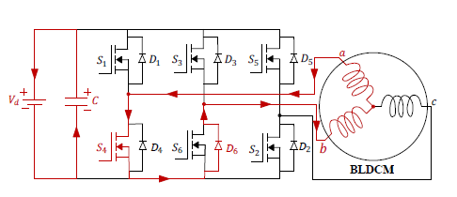

Figure 44: storing mode of BLDC

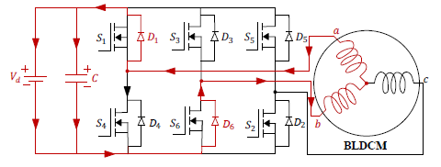

Figure 45: storing mode of BLDC

Electric braking to above drive can be implemented in three ways namely Dynamic Braking, Plugging and Regenerative Braking

Figure 2 Energizing mode of BLDC

**| CH4 | Braking**

**4.1 Dynamic Braking**

Dynamic braking is bringing the machine to rest position by dissipating the kinetic energy possessed by the rotor of motor in the form of heat energy through some external resistance

This braking can be implemented by disconnecting the power supply to windings and short circuiting them.

The short circuit windings carrying higher magnitudes of current will damage the windings.

To limit the short circuit current flowing in these windings, an external resistance R is connected in series with the windings. This resistance is used to limit current and is called braking resistance.

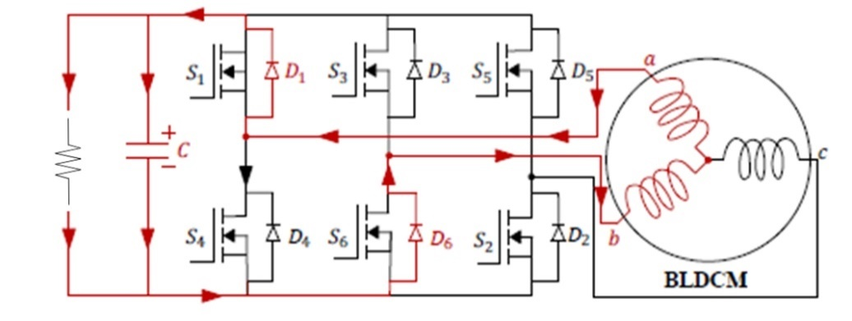Thus, the power generated in the three stator windings during braking is wasted in the external resistance.

Figure 46: storing mode of BLDC

The equation of speed during normal operation is

**ω= (V/K) - (R*T)/Kt**

For dynamic braking V=0, then the speed equation becomes

**ω= - (R*T)/Kt**

Here R is the resistance of winding after insertion of braking resistance. So during dynamic braking the speed-torque relation is in the form of a straight line which passes through the origin with a negative slope of –R/K2

In single stage dynamic braking method, the braking and energy regeneration are achieved by the use of single stage bidirectional DC/AC converter which is used to drive the BLDC motor.

The BLDC motor driven by a single stage bidirectional converter A dedicated controller is used to switch the inverter in a particular fashion based on the rotor position received from hall sensors Ha; Hb and Hc.

The switching sequences and the switches incorporated in achieving various braking methods such as single switch, two switch, three switch, and plugging

**| CH4 | Braking**

* Single switch

In single switch braking method, only one switch out of switches (lower switches) S2, S4, S6 is operated in pulse width modulation (PWM) switching mode at each commutation state

* Two switches

In two switch method, two switches out of switches S1-S6 are operated in PWM switching mode at each commutation state

* Three switches

In three switch method, three switches S2, S4, S6 are operated in PWM switching mode at the same time in each commutation state

* plugging

The switching sequence of plugging is similar to that of two switch method, where a continuous signal is applied instead of PWM pulses

Simulink model

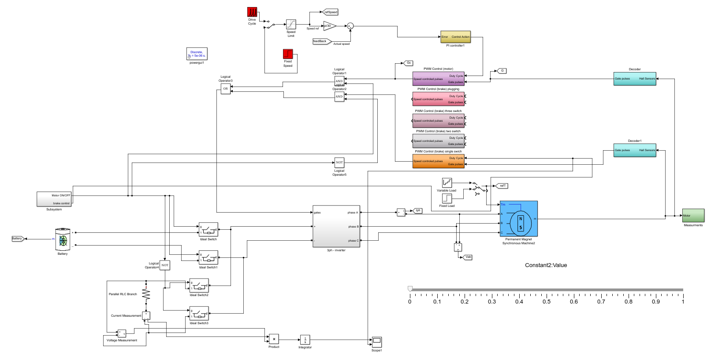

Figure 47: storing mode of BLDC

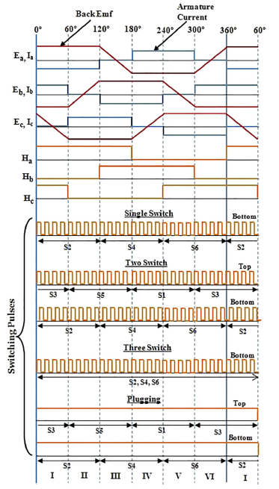**| CH4 | Braking**

Figure 48: storing mode of BLDC

**| CH4 | Braking**

The performance indices of these braking methods such as braking torque and stopping from simulation time are presented in this Tables

|  |  |  |
| --- | --- | --- |
| Duty | Stopping time | Braking torque |
| 0.1 | 2.382 | -1 |
| 0.2 | 2.268 | -1.9 |
| 0.3 | 2.097 | -2.2 |
| 0.4 | 1.919 | -3 |
| 0.5 | 1.744 | -4 |
| 0.6 | 1.483 | -5 |
| 0.7 | 1.214 | -7 |
| 0.8 | 0.825 | -13 |
| 0.9 | 0.625 | -17.6 |

**Single switch**

|  |  |  |
| --- | --- | --- |
| Duty | Stopping time | Braking torque |
| 0.1 | 2.215 | -1.2 |
| 0.2 | 1.954 | -1.7 |
| 0.3 | 1.355 | -2.3 |
| 0.4 | 0.907895 | -15.4 |
| 0.5 | 0.48684 | -24.7 |
| 0.6 | 0.4342 | -29.2 |
| 0.7 | 0.41648 | -33 |
| 0.8 | 0.416041 | --36.9 |
| 0.9 | 0.421 | -38.1 |

**Two switches**

**| CH4 | Braking**

**Three switches**

|  |  |  |
| --- | --- | --- |
| Duty | Stopping time | Braking torque |
| 0.1 | 2.364 | -1.25 |
| 0.2 | 2.279 | -1.83 |
| 0.3 | 2.116 | -2.32 |
| 0.4 | 1.900 | -3.17 |
| 0.5 | 1.655 | -4.13 |
| 0.6 | 1.434 | -5.03 |
| 0.7 | 1.164 | -7.3 |
| 0.8 | 0.8584 | -11.9 |
| 0.9 | 0.588 | -18.35 |

**Plugging**

|  |  |  |
| --- | --- | --- |
| Duty | Stopping time | Braking torque |
| 0.1 | 0.427 | -41 |
| 0.2 | 0.427 | -41 |
| 0.3 | 0.427 | -41 |
| 0.4 | 0.427 | -41 |
| 0.5 | 0.427 | -41 |
| 0.6 | 0.427 | -41 |
| 0.7 | 0.427 | -41 |
| 0.8 | 0.427 | -41 |
| 0.9 | 0.427 | -41 |

**| CH4 | Braking**

**Plotting all results**

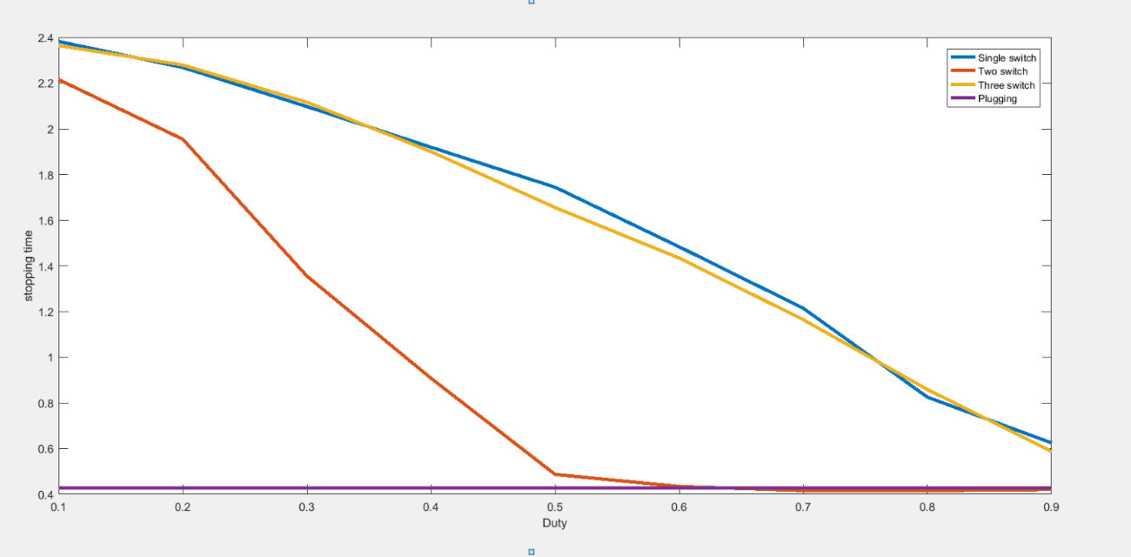

Figure 49: storing mode of BLDC

**3.3 Proposed braking system**

Based on the results obtained from the performance evaluation of various braking methods, a new braking strategy is proposed based on stopping time(deceleration) and energy recovery. The strategy switches the braking methods in a sequence as shown below based on the brake pedal depression. The brake pedal employed here is a linear hall effect based pedal whose output voltage varies between 0.85 V and 4.2 V when depressed from 0 to 18 degree . A tolerance of 3 degree is given from the initial point of the brake pedal as a safety measure and no braking method is applied. When the pedal is depressed above 3 degree, the single switch is activated and again when depressed above 8 degree, three switch is activated. Above 13 degree, two switch is activated and at 18 degree, plugging is activated. As single switch and three switch has less deceleration and more energy recovery, it is adapted for normal braking event or deceleration purpose. Hence, these methods are placed at the initial angle (3 –13 ) degree of the brake pedal. As the deceleration of two switch and plugging is high, two switch is adapted for rapid stopping condition and plugging for emergency cases. So these methods are placed at the final angle (13 –18 ) degree of the brake pedal

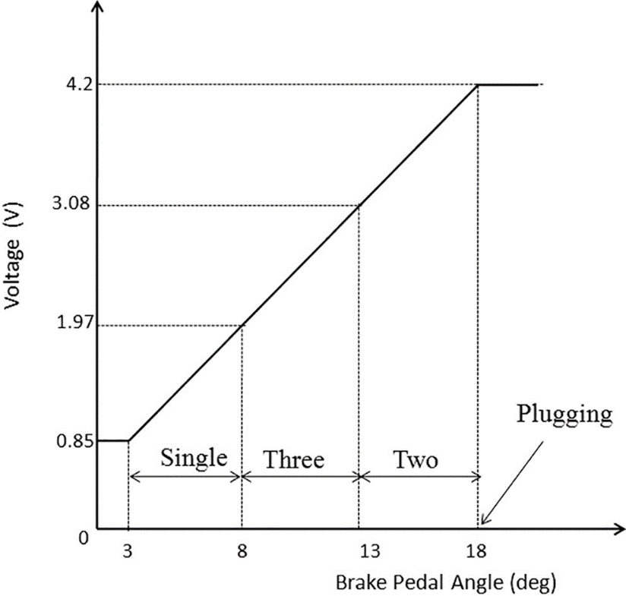

## **Regenerative Braking**

In regenerative braking, instead of wasting the power in external resistance the power generated during retardation is fed back towards the source i.e., the motor works as a generator developing a negative torque which opposes the motion and the generated energy is supplied to the source.

For the generated energy to be supplied to the source two conditions should be satisfied

1. back emf should be greater than supply voltage (E > V) for all speeds
2. Current has to reverse its direction

For the above two conditions to be satisfied, increase the back emf so that it is greater than the supply voltage.

In order to increase the back emf, increase the speed. The speed increases when the EV is moving down the gradient or by increasing the field flux. But increasing the field flux beyond rated is not possible as the permanent magnets are used in field system or we can use boost converter to overcome the supply voltage.

So, for a source of fixed voltage of rated value regenerative braking is possible only for speeds higher than rated value and for a variable voltage source it is possible for below rated speeds also.

During regeneration if the generated power is not absorbed by the load, it will be supplied to the line and the line voltage will rise to dangerous values leading to insulation break down. Hence regenerative braking should be used only when there are loads connected to absorb regenerated power

During regeneration the DC-link capacitor stores the energy recovered from the load through the anti-parallel diodes across the switches.

To limit the capacitor C voltage to a safer value Switch S0 is used to dissipate the excess energy through the resistor.

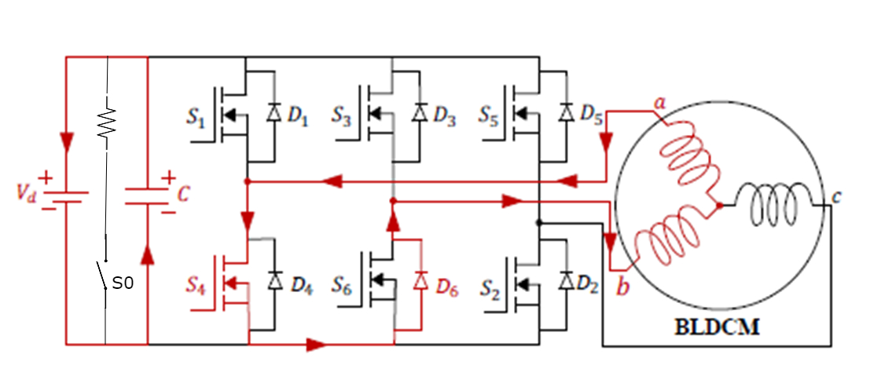

Figure 50: storing mode of BLDC (regenerative)

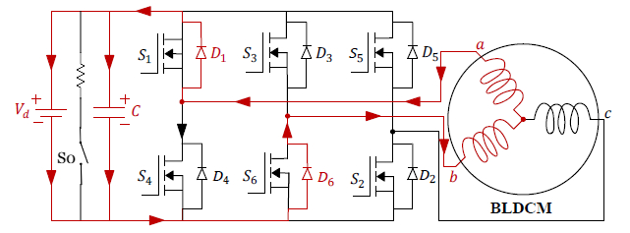

Figure energizing mode of BLDC (regenerative)

The speed equation during regeneration becomes

**ω = (V/K) - (R*T)/K2**

The above equation is of the form of a straight line with a positive intercept. As we keep on decreasing the voltage with reference to back emf, the voltage becomes zero finally. Thus, the speed equation becomes

**ω = (V/K) + (R*T)/K2**

So during regenerative braking the speed-torque relation is in the form of a straight line which passes through the origin with a slope of R/K2.

**| CH4 | Braking**

## 3.2 **Plugging**

Plugging is a method of braking obtained by reversing the applied supply voltage, so that the input voltage assists t i) he back emf in forcing armature current in reverse direction.

This reversed current will have impact on torque, thus producing deceleration. Plugging provides faster braking response because braking torque is high as the magnitude of current during this braking is high.

Even though plugging provides faster braking response it is highly in-efficient because in addition to generated power, the power supplied by the source is also wasted in resistances and plugging increases the inverter rating also.

Plugging can be implemented to the drive in figure.1 by reversing the voltage (by high speed switches) and a braking resistance is connected just as in dynamic braking.

The speed equation now becomes

**ω = (-V/K) - (R*T)/K2 (8)**

So plugging provides torque at zero speed. when reverse voltage is applied for stopping the EVs the supply must be disconnected at the instant where speed is close to zero. Otherwise it will rotate in reverse direction (reverse motoring takes place).

The speed-torque relation is of the form of a straight line with a negative intercept. Thus the speed-torque plot during plugging doesn’t pass through origin, it is a straight line having a slope of **–R/K2** and having a negative intercept of **–V/K.**

## **Regenerative Braking**

In regenerative braking, instead of wasting the power in external resistance the power generated during retardation is fed back towards the source i.e., the motor works as a generator developing a negative torque which opposes the motion and the generated energy is supplied to the source.

For the generated energy to be supplied to the source two conditions should be satisfied

1. back emf should be greater than supply voltage (E > V) for all speeds
2. Current has to reverse its direction

For the above two conditions to be satisfied, increase the back emf so that it is greater than the supply voltage.

In order to increase the back emf, increase the speed. The speed increases when the EV is moving down the gradient or by increasing the field flux. But increasing the field flux beyond rated is not possible as the permanent magnets are used in field system.

Boost converter may be good solution to increase voltage level above battery voltage

So, for a source of fixed voltage of rated value regenerative braking is possible only for speeds higher than rated value and for a variable voltage source it is possible for below rated speeds also.

During regeneration if the generated power is not absorbed by the load, it will be supplied to the line and the line voltage will rise to dangerous values leading to insulation break down. Hence regenerative braking should be used only when there are loads connected to absorb regenerated power

During regeneration the DC-link capacitor stores the energy recovered from the load through the anti-parallel diodes across the switches.

To limit the capacitor C voltage to a safer value Switch S0 is used to dissipate the excess energy through the resistor.



Figure 50: storing mode of BLDC

The speed equation during regeneration becomes

**ω = (V/K) - (R*T)/K2**

The above equation is of the form of a straight line with a positive intercept. As we keep on decreasing the voltage with reference to back emf, the voltage becomes zero finally. Thus, the speed equation becomes

**ω = (V/K) + (R*T)/K2 (10)**

So during regenerative braking the speed-torque relation is in the form of a straight line which passes through the origin with a slope of R/K2.

**| CH5 | IoT**

**CHAPTER 4 || Internet of Things (IoT)**

**4.1 Introduction**

An IoT ecosystem consists of web-enabled smart devices that use embedded systems, such as processors, sensors and communication hardware, to collect, send and act on data they acquire from their environments. [IoT devices](https://internetofthingsagenda.techtarget.com/definition/IoT-device) share the sensor data they collect by connecting to an IoT gateway or other edge device where data is either sent to the cloud to be analyzed or analyzed locally. Sometimes, these devices communicate with other related devices and act on the information they get from one another. The devices do most of the work without human intervention, although people can interact with the devices -- for instance, to set them up, give them instructions or access the data.

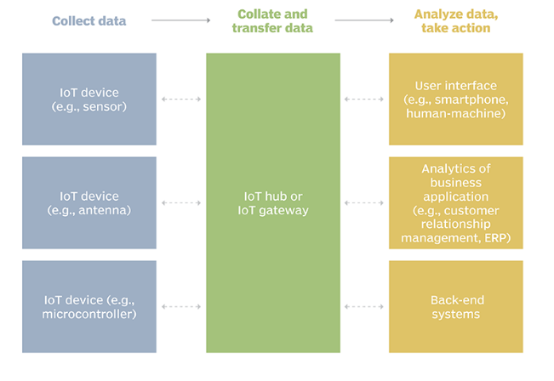

Figure 51: Internet of Things

**| CH5 | IoT**

**4.2 Why IoT is important?**

The internet of things helps people live and work smarter, as well as gain complete control over their lives. In addition to offering smart devices to automate homes, IoT is essential to business. IoT provides businesses with a real-time look into how their systems really work, delivering insights into everything from the performance of machines to supply chain and logistics operations.

IoT enables companies to automate processes and reduce labor costs. It also cuts down on waste and improves service delivery, making it less expensive to manufacture and deliver goods, as well as offering transparency into customer transactions.

As such, IoT is one of the most important technologies of everyday life, and it will continue to pick up steam as more businesses realize the potential of connected devices to keep them competitive.

**4.3 IoT Implementation in Electric Vehicle**

Adding IoT to an electric vehicle transform it from just a project to real product which companies can produce, every electrical appliance nowadays has a mobile application to monitor or control them or sharing the data remotely, and this make the life very easy, here in our project you may want to read the distance you traveled or state of charge of the battery or you want to set point for speed to drive your vehicle with a constant speed.

All these data can simply share via internet with two devices and one server using different communication protocols such as UART and Ethernet, before going through the implementation of the IoT you should know that the IoT physical component you need is mobile app, MC, and modem.

**| CH5 | IoT**

**4.4 IoT Components and Hardware Connection**

In our project the physical components we used for IoT are:

* Microcontroller

This is the slave microcontroller which is responsible for the communication between the main microcontroller and the temperature sensor.

* Wi Fi Module (ESP8266)
* Mobile App

Send control commands and monitor the vehicle parameters.

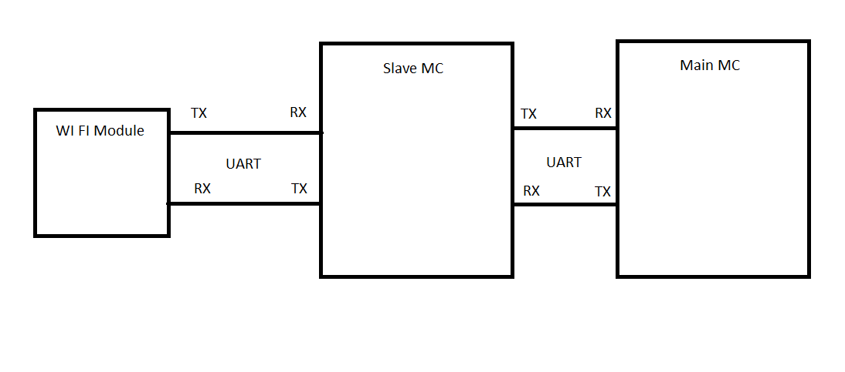The following figure will illustrate the connection between the two controllers, ESP and the sensors.

Figure 32: IoT hardware Connection

As we see in the previous figure, we used UART communication Protocols to communicate with the different devices.

UART and HTTP Protocols

UART, or universal asynchronous receiver-transmitter, is one of the most used device-to-device communication protocols. This article shows how to use UART as a hardware communication protocol by following the standard procedure we implemented UART in our project because it is very simple.

**| CH5 | IoT**

**UART advantages**

* Requires only two wires for full duplex data transmission (apart from the power lines).
* No need for clock or any other timing signal.
* Parity bit ensures basic error checking is integrated in to the data packet frame.

When properly configured, UART can work with many different types of serial protocols that involve transmitting and receiving serial data. In serial communication, data is transferred bit by bit using a single line or wire. In two-way communication, we use two wires for successful serial data transfer. Depending on the application and system requirements, serial communication needs less circuitry and wires, which reduces the cost of implementation.

Embedded systems, microcontrollers, and computers mostly use UART as a form of device-to-device hardware communication protocol. Among the available communication protocols, UART uses only two wires for its transmitting and receiving ends.

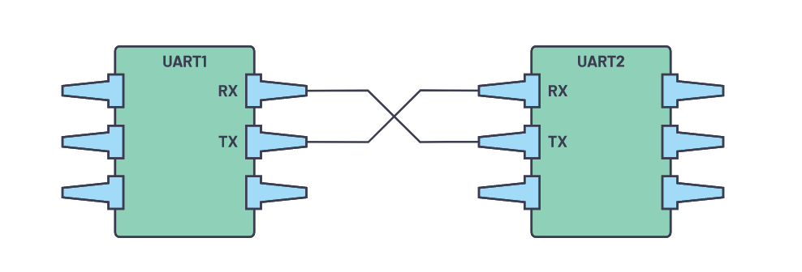

Figure 53: UART Interface

For UART and most serial communications, the baud rate needs to be set the same on both the transmitting and receiving device. The baud rate is the rate at which information is transferred to a communication channel. In the serial port context, the set baud rate will serve as the maximum number of bits per second to be transferred.

**| CH5 | IoT**

**Data Transmission**

In UART, the mode of transmission is in the form of a packet. The piece that connects the transmitter and receiver includes the creation of serial packets and controls those physical hardware lines. A packet consists of a start bit, data frame, a parity bit, and stop bits.

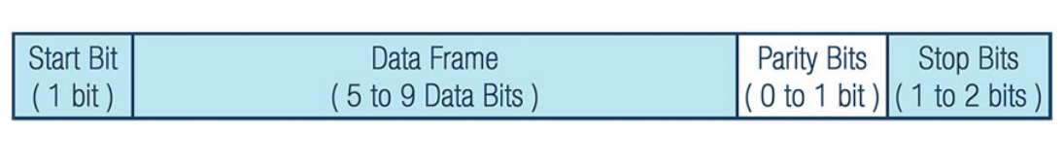

Figure 54: Data Packet

**Start Bit**

The UART data transmission line is normally held at a high voltage level when it’s not transmitting data. To start the transfer of data, the transmitting UART pulls the transmission line from high to low for one (1) clock cycle. When the receiving UART detects the high to low voltage transition, it begins reading the bits in the data frame at the frequency of the baud rate.

***Data Frame***

The data frame contains the actual data being transferred. It can be five (5) bits up to eight (8) bits long if a parity bit is used. If no parity bit is used, the data frame can be nine (9) bits long. In most cases, the data is sent with the least significant bit first.

***Parity***

Parity describes the evenness or oddness of a number. The parity bit is a way for the receiving UART to tell if any data has changed during transmission. Bits can be changed by electromagnetic radiation, mismatched baud rates, or long-distance data transfers.

***Stop Bits***

To signal the end of the data packet, the sending UART drives the data transmission line from a low voltage to a high voltage for one (1) to two (2) bit(s) duration.

**| CH5 | IoT**

The entire packet is sent serially starting from start bit to stop bit from the transmitting UART to the receiving UART. The receiving UART samples the data line at the preconfigured baud rate.

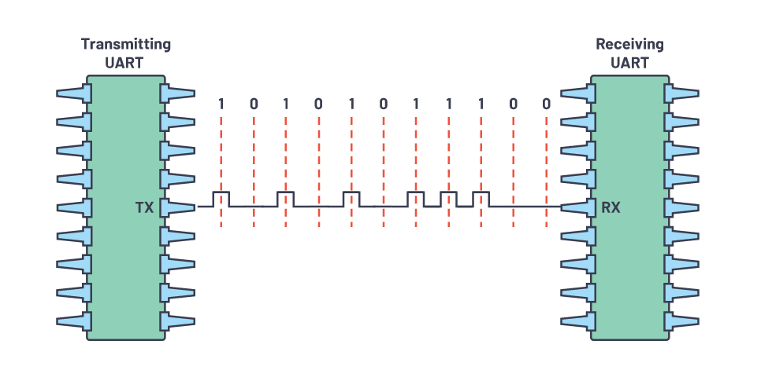

Figure 55: Data sending bit by bit

**HTTP Protocol**

We used HTTP to communicate between end-point devices (ESP and Mobile) with the internet.

**What is HTTP?**

The Hypertext Transfer Protocol (HTTP) is the foundation of the World Wide Web, and is used to load web pages using hypertext links. HTTP is an [application layer](https://www.cloudflare.com/learning/ddos/application-layer-ddos-attack/) protocol designed to transfer information between networked devices and runs on top of other layers of the network protocol stack. A typical flow over HTTP involves a client machine making a request to a server, which then sends a response message.

**| CH5 | IoT**

**What’s in an HTTP request?**

An HTTP request is the way internet communications platforms such as web browsers ask for the information, they need to load a website.

Each HTTP request made across the Internet carries with it a series of encoded data that carries different types of information. A typical HTTP request contains:

1. HTTP version type
2. a URL
3. an HTTP method
4. HTTP request headers
5. Optional HTTP body.

Let’s explore in greater depth how these requests work, and how the contents of a request can be used to share information.

**What’s an HTTP method?**

An HTTP method, sometimes referred to as an HTTP verb, indicates the action that the HTTP request expects from the queried server. For example, two of the most common HTTP methods are ‘GET’ and ‘POST’; a ‘GET’ request expects information back in return (usually in the form of a website), while a ‘POST’ request typically indicates that the client is submitting information to the web server (such as form information, e.g. a submitted username and password).

**What are HTTP request headers?**

HTTP headers contain text information stored in key-value pairs, and they are included in every HTTP request (and response, more on that later). These headers communicate core information, such as what browser the client is using what data is being requested.

**| CH5 | IoT**

Example of HTTP request headers from Google Chrome's network tab:

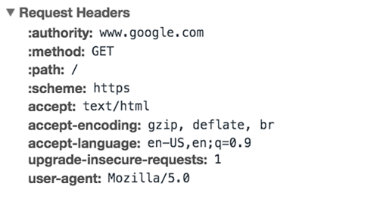

Figure 56: HTTP Request Header

**What’s in an HTTP request body?**

The body of a request is the part that contains the ‘body’ of information the request is transferring. The body of an HTTP request contains any information being submitted to the web server, such as a username and password, or any other data entered into a form.

**What’s in an HTTP response?**

An HTTP response is what web clients (often browsers) receive from an Internet server in answer to an HTTP request. These responses communicate valuable information based on what was asked for in the HTTP request.

A typical HTTP response contains:

1. an HTTP status code
2. HTTP response headers
3. optional HTTP body

Let's break these down:

**| CH5 | IoT**

***What’s an HTTP status code?***

HTTP status codes are 3-digit codes most often used to indicate whether an HTTP request has been successfully completed. Status codes are broken into the following 5 blocks:

* 1. 1xx Informational
  2. 2xx Success
  3. 3xx Redirection

1. 4xx Client Error
2. 5xx Server Error

The “xx” refers to different numbers between 00 and 99.

Status codes starting with the number ‘2’ indicate a success. For example, after a client requests a web page, the most commonly seen responses have a status code of ‘200 OK’, indicating that the request was properly completed.

If the response starts with a ‘4’ or a ‘5’ that means there was an error and the webpage will not be displayed. A status code that begins with a ‘4’ indicates a client-side error (It’s very common to encounter a ‘404 NOT FOUND’ status code when making a typo in a URL). A status code beginning in ‘5’ means something went wrong on the server side. Status codes can also begin with a ‘1’ or a ‘3’, which indicate an informational response and a redirect, respectively.

***What are HTTP response headers?***

Much like an HTTP request, an HTTP response comes with headers that convey important information such as the language and format of the data being sent in the response body.

Example of HTTP response headers from Google Chrome's network tab:

**| CH5 | IoT**

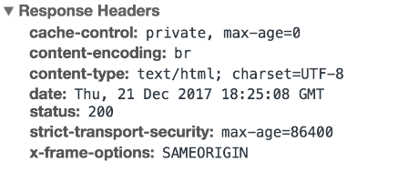

Figure 57: HTTP Response Header

**What’s in an HTTP response body?**

Successful HTTP responses to ‘GET’ requests generally have a body which contains the requested information. In most web requests, this is HTML data which a web browser will translate into a web page.

**4.5 Data Transfer in The Project**

After we know the main component and the hardware connection then the communication protocols, now we will discuss how the data transfer happened in our project.

The following figure will illustrate the flow of data and how can be shared with all end-point-devices (ESP and mobile app)

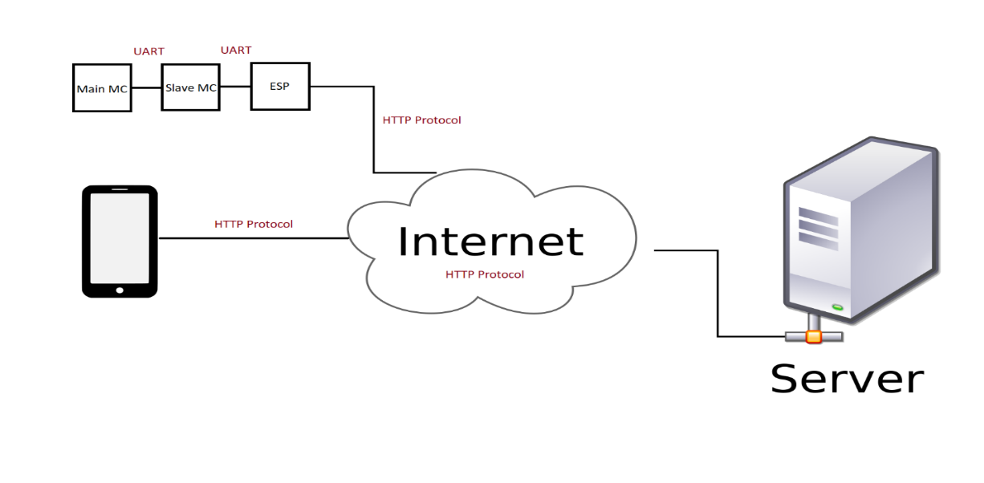

Figure 58: Data Transfer over Internet

**| CH5 | IoT**

Software Implementation

To start communication between our devices, first we implement the microcontroller code for slave and main controller using C programming language then we make android app using Flutter framework and Dart programming language.

**Slave Microcontroller**

Slave MC is responsible for receive the actual speed of the motor from the main MC and receive the temperature value then send these data to WIFI module (ESP) via UART.

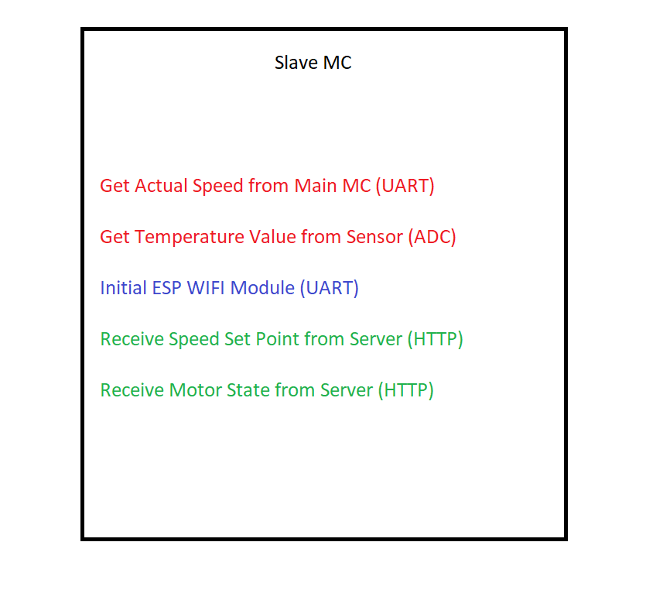

Figure 59: Slave MC Tasks

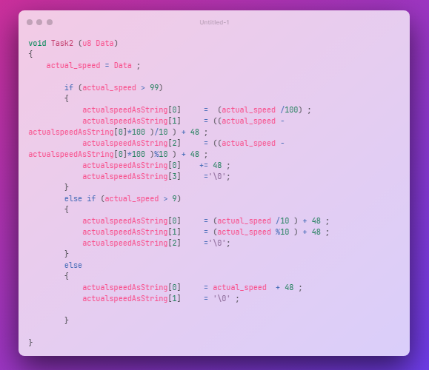**| CH5 | IoT**

Figure 60: Get actual speed from main MC

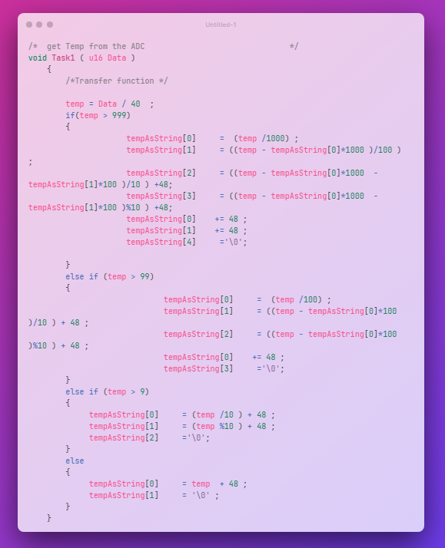

Figure 61: Get The analog temperature value from the sensor

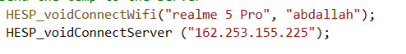

Figure 62: ESP initialization

**| CH5 | IoT**

Send actual speed and temperature value to the server

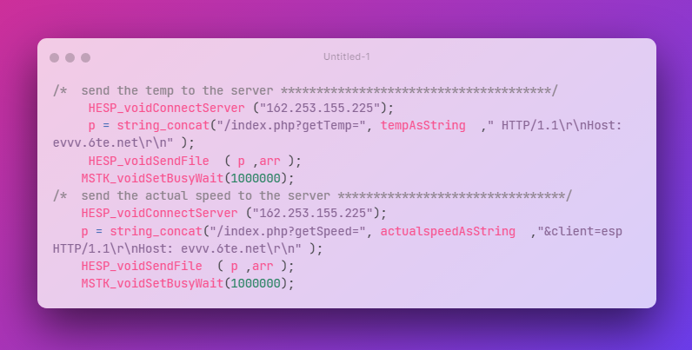

Figure 42: Send Data to the Server

Receive data from the server

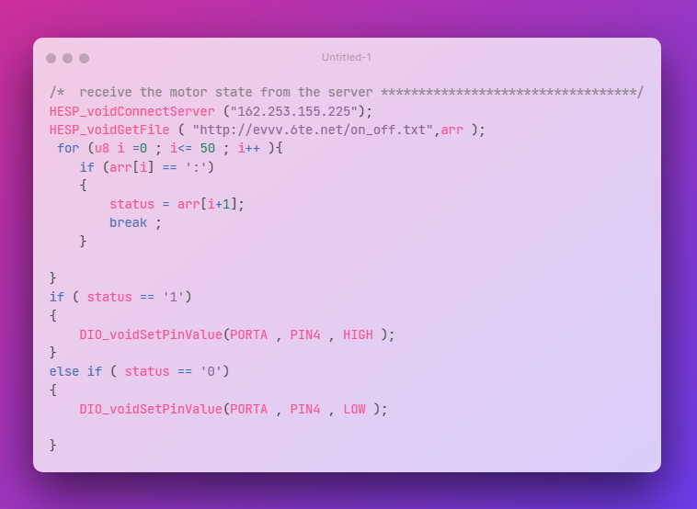

Figure 63: Receive Motor State

**| CH5 | IoT**

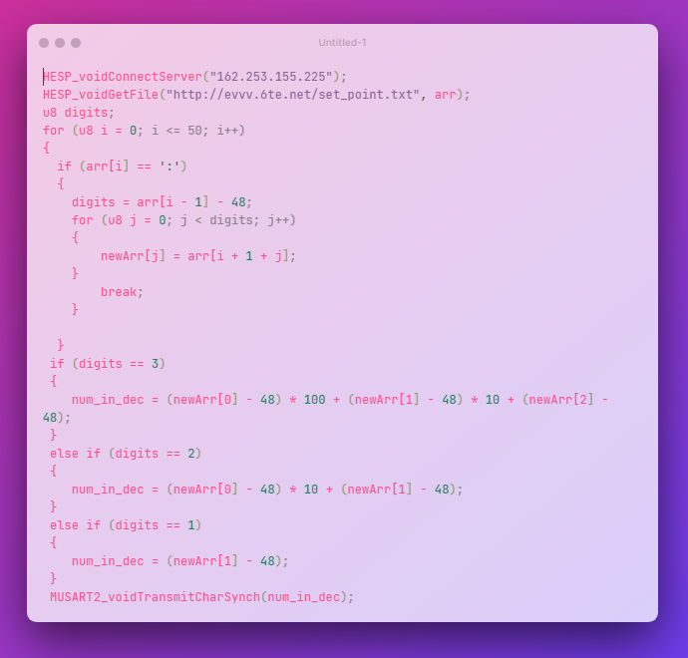

Figure 64: Receive Speed Set Point

**| CH5 | IoT**

**Main Microcontroller**

Main MC is responsible for receive the set-point speed of the motor from the slave MC and send the actual speed of the motor to it via UART.

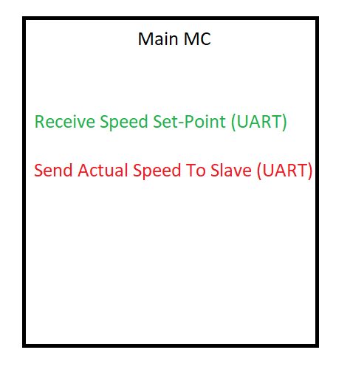

Figure 5: Main MC IoT Tasks

Receive set-point speed

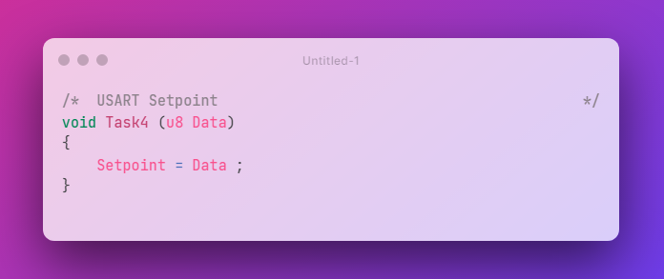

Figure 66: Receive set-point speed via UART

**| CH5 | IoT**

Calculating speed and send it to slave MC

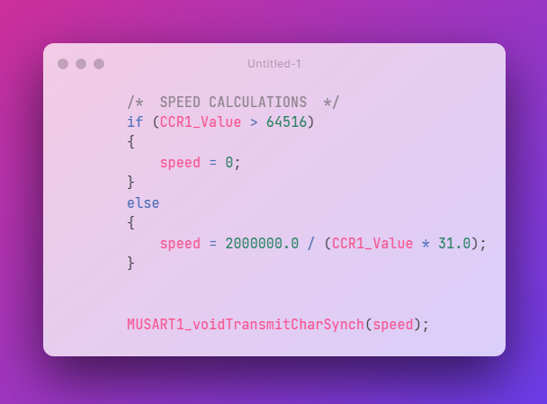

Figure 6: Sending Speed Via UART

**| CH5 | IoT**

**4.6 Mobile App Implementation**

We implement a mobile app using Dart programming language and Flutter framework to receive and send data to the server then it can control and monitor all the process data, the mobile app communicates with server using HTTP protocol to send and receive data.

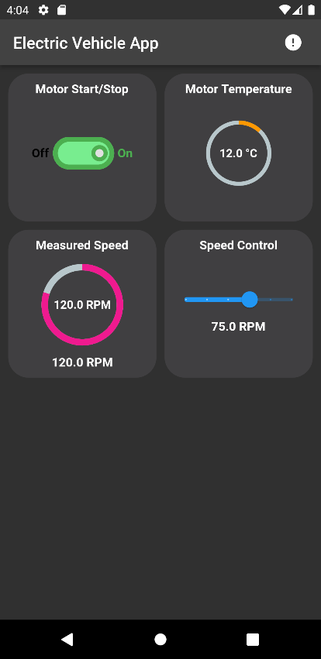

Figure68: Mobile app UI

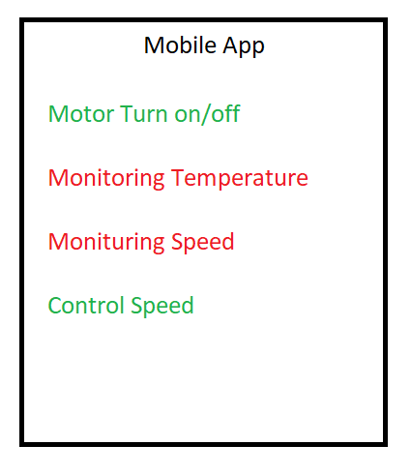

Figure 69: Mobile App Tasks

**| CH5 | IoT**

Send Command to turn motor on or off

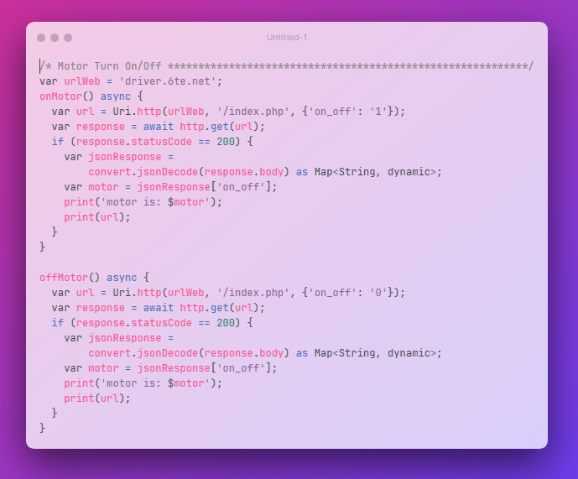

Figure 70: Send Command to turn motor on or off

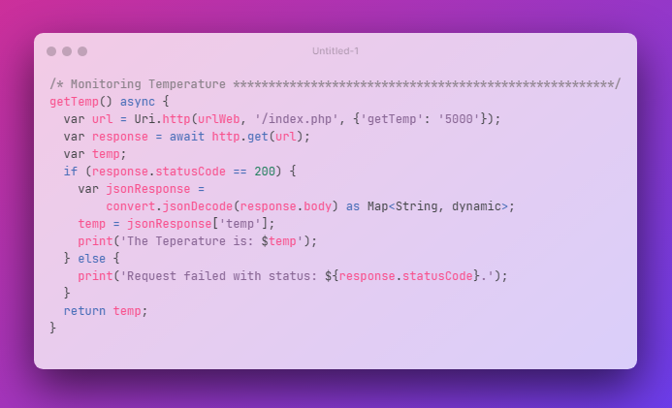Receiving temperature from server

Figure 71: Receiving temperature from server

**| CH5 | IoT**

Receiving actual speed from the server

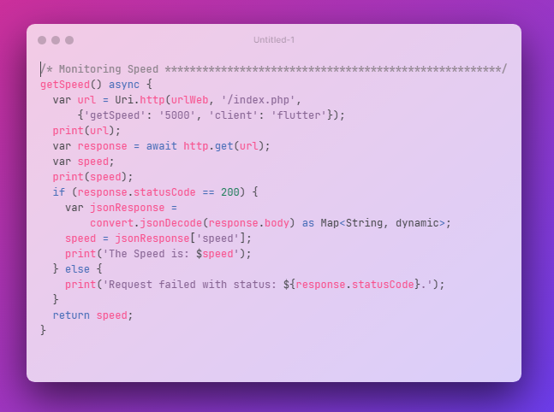

Figure 727: Receiving actual speed from the server

Send speed set-point to the server

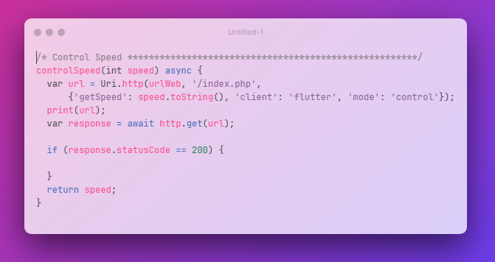

Figure 83: Send speed set-point to the server

**| CH5 | IoT**

**4.7 PHP Server**

a server is a piece of [computer](https://en.wikipedia.org/wiki/Computer) hardware or software ([computer program](https://en.wikipedia.org/wiki/Computer_program)) that provides functionality for other programs or devices, called "[clients](https://en.wikipedia.org/wiki/Client_(computing))". This [architecture](https://en.wikipedia.org/wiki/Systems_architecture) is called the [client–server model](https://en.wikipedia.org/wiki/Client%E2%80%93server_model). Servers can provide various functionalities, often called "services", such as sharing data or [resources](https://en.wikipedia.org/wiki/System_resource) among multiple clients, or performing [computation](https://en.wikipedia.org/wiki/Computation) for a client.

We implemented our code here in a free we hosting server that support PHP language we used in our program.

**| CH5 | IoT**

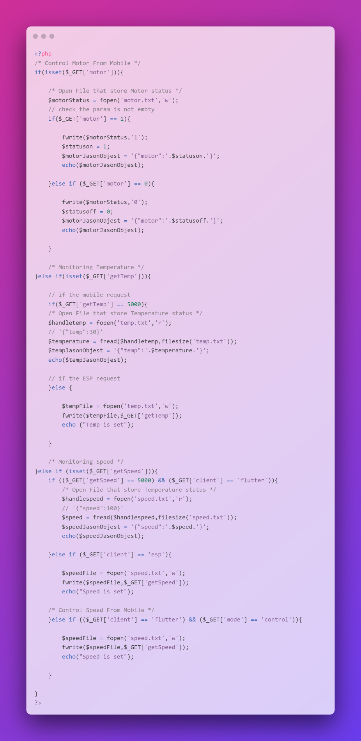

Figure 74: Server-Side Code

**Conclusion**

At the end of this book, we would like to tell you that this project has not reached the end line yet, there is certainly work and several additions that can be completed in the near future, and this is a very normal thing in any engineering project. There are always details that can be completed and features to be added to bring the project out in the best possible way, but Whatever you do, you will not reach the stage of perfection due to your connection with a specific time and dates for the completion of the project, but if we look from a little distance, we will see that we have actually achieved the main outputs of the project, which are the complete design of an electric vehicle propulsion system with its communication and Internet of Things and the implementation of a prototype that can be completely relied upon and used to produce electric vehicles in the local markets Which will benefit the companies investing in this project and also the markets, as they will be local products free from customs and additional taxes. And last but not least, I would like to say that in light of the current trend of the country in the production of electric vehicles and the preservation of the environment from the exhausts of cars, the good investment in this project will be a quick and rewarding return. If all the working mechanisms are available to work on implementing the idea now, it will turn within two years from just an idea and a prototype to a product that is sold in the local markets.

References

1. Performance Improvement of BLDC Motor with Hysteresis Current Controller A.Purna Chandra Rao1, Y.P.obulesh2, CH. Sai babu3
2. Dept. Of EEE, Prasad V. Potluri Siddhartha Institute of Technology, Vijayawada, Andhra Pradesh, India 1
3. Dept. Of EEE, Lakireddy Bali Reddy College of Engineering, Mylavaram, Andhra Pradesh, India 2
4. Dept. Of EEE, Jawaharlal Nehru Technological University Kakinada, Kakinada, Andhra Pradesh, India 3